10/7/2024
Adult Mental Health State Program Standing Committee Minutes
FINAL

Attendance
Members Present: Ann Cooper (she/her), Lynne Cardozo, Marla Simpson (she/they), Christopher Rotsettis (he/him), Thelma Stoudt, Zack Hughes (he/him), Bruce Wilson, Dan Towle
Members Absent: Michael McAdoo (excused)
DMH/State Staff Present: Lauren Welch (she/her), Trish Singer (she/her)
Presenters: Nick Nichols, VDH
Public: Aaron Kelly, Laurie Mulhern (Children’s SPSC, Mental Health Block Grant), Carly L (CARES Clinician with Burlington Police)

Agenda
- 12:30 Standing Committee Business: Introductions, Review Agenda, Statement on Public Comment, Announcements, Vote on minutes, Assign questions
- 1:00 Update: VDH Suicide Prevention
- 1:20 Break (as needed)
- 1:30 Designation Q&A: Pathways Vermont
- 2:30 Leadership Update: CRT and conflict of interest
- 2:45 Draft Recommendation to the Commissioner
- 2:55 Public Comment, Closing meeting business, Plan next meeting agenda

Minutes
Follow-up items highlighted
Meeting Chair: Marla Simpson

Opening Committee Business
Meeting convened at 12:35PM. Quorum was met. Reviewed agenda. Introductions.
Announcements
- No announcements were made
Previous Meeting Minutes
Zack motioned to accept September 2024 meeting minutes with edits. Dan seconded. All in favor. One abstention. September minutes were accepted with edits.
Edits:
  - Add page numbers
  - Move the comment about Kristen Kellett to bottom as a note to Lauren
  - Rename header that read “Concerns for Pathways” to “Concerns that arose for Pathways and/or the State at large” since some of the coordinated entry and CRT questions aren’t specifically directed at Pathways.
  - Moved question about Support Line referring to Housing First to the visit questions.
Assign Questions for Pathways Visit
- Names are listed after each question in the Q&A section.

Update: Vermont Department of Health Suicide Prevention Grant
Started with introductions.
Nick Nichols, VDH Suicide Prevention Program Coordinator (Nick.Nichols@vermont.gov)
Slides included in Appendix
- Comment on the goal of a 10% reduction in suicide mortality over 5 years
  - Doesn’t feel like an aggressive enough goal. Not a very visionary number.
  - Nick agreed with this perception, but also brought up that suicide rate is on the rise.
  - This may warrant further discussion.
- What aspects of the State’s suicide prevention efforts have been successful?
  - Awareness raising and training for at-risk populations
    - Trained over 300 Vermonters to feel more comfortable starting conversations about suicide.
    - In a 6-month follow-up survey, trainees said they had made a total of about 500 referrals to care.
  - Partnering with emergency departments
    - All 14 emergency departments in Vermont have signed on to work with the State and develop protocols for supporting people who present with suicidal ideation.
- For Pathways Support Line operators, what would be the best door for referring callers to further care?
  - How to protect callers from being forced into the medical model of care and treatment for suicidal ideation
  - The awareness trainings and starting conversation trainings aim to make folks more comfortable sitting with someone who has suicidal ideation rather than jumping straight to treatment options.
- Further follow up questions were sent to Nick via email.
  - What aspects of the State’s suicide prevention efforts have been challenging or least successful?
    - Email response from Nick on 10/8/24: “Regarding challenges, here are some of the activities that have been more challenging – we are making progress in these areas, but the progress is much slower going:
      - Changing attitudes and practices among gun-owners to safely store their firearms and ammunition
      - Engaging with the gun-owning community to support suicide prevention awareness
      - Staff turnover and vacancies among healthcare providers can undo or slow implementation of suicide prevention in their agencies”
  - How is Alternatives to Suicide being incorporated in the existing prevention work?
    - Email response from Nick on 10/8/24: “Regarding Alternatives to Suicide, we have been very happy to partner with the Wildflower Alliance, the creator of Alternatives to Suicide, to sponsor multiple training sessions on alternative approaches to suicide prevention. We have not specifically sponsored training on how to develop Alternatives to Suicide support groups, but I believe DMH has focused on that in the past couple of years through their work with the Center for Health and Learning.”
  - More from Nick via email on 10/8/24: “Happy to come back again in the future for additional conversations. Also…if anyone is interested in coming to our next grant Advisory group, please have them reach out to me and I’ll share the date, time, and link for joining.”

Designation Q&A: Pathways Vermont
Started with introductions.
Lindsay Mesa (she/her), Assistant Director
Cheryl Jackins (she/her), Housing First Program Director
Chelsea Alsofrom (she/her), Director of Program Administration
Pathways responses in GREEN
- Starting off positive - Zack
  - What are some strengths of Pathways?
    - Shared set of values and desire to support community through those values
  - What are some stellar moments at Pathways that are making you proud
    - Monthly all staff on Diversity and Inclusion such as health at every size, disability rights, cultural competence/humility.
- Pathways excels in employment, retention, leadership, and relationships. -Zack
  - What words of wisdom does Pathways have for other agencies trying to cultivate this culture?
    - Humility: Pathways doesn’t have all the answers, but the most important resource they have is each other’s humanness
    - Zack praised the Pathways website as being a very laid back space
  - To what extent does employment of people with lived experience help cultivate this?
    - Opportunity to build a different kind of relationship with the community that in fundamentally community-based
- How does Pathways do Housing First during this housing crisis (skyrocketing rent, Airbnb, low vacancy)? To the extent that you have influence, how is Pathways involved in trying to turn the curve on lack of affordable housing in Vermont?
  - The model is the same as always even though the choices available are more limited.
  - In Vermont we’re experiencing a much more visible experience of homelessness than ever before. So, part of the work is about educating the public that homelessness is a housing problem. Showing a film called “Beyond the Bridge: A Solution to Homelessness”
  - Does Pathways have any experience with human trafficking and drug trafficking related to the housing crisis? -Dan
- How does Pathways work on homelessness prevention? – Dan
  - Unofficial model: Try, try, and try again. There’s nothing a Pathways client can do that will make them not want to help them find housing.
  - Building and maintaining relationships with landlords
- What kind of housing options does Pathways pursue? Primarily private homes? Therapeutic residential? Group homes? Homesharing? – Dan
  - Predominantly private individual apartments. Some clients may enter or receive residential mental health services, and Pathways will support them through that, but with the intention to find permanent housing.
- Why does Pathways only serve parts of the state and not others? -Christopher
  - Main reason is funding. Aspiration is that Pathways is a resource for every Vermonter needing Housing First.
  - How is Pathways working to expand services into underserved areas such as the Northeast Kingdom and Rutland and Orange Counties.
    - Requesting funding from existing funders and the legislature.
    - Expansion relies on local groundswell of interest from the community.
- What does recruitment look like for Pathways particularly when the starting pay of $20 isn’t really a livable wage in many parts of the state. – Christopher
  - Advocating for increased pay to keep up with the cost of living and to properly value the unique work that Pathways staff undertakes.
  - Recruitment is mostly mission-driven because they attract people who really want to do this work.
  - Values formal education and work experience in addition to lived experience. Looks for different ways that potential staff leverage experience in the work.
- Quote from page 4 of the Site Visit Report: “The Board has had concerns about the coordinated entry system acting as a barrier to clients getting housing.”
  - Would Pathways consider allowing, for example, Support Line workers to make referrals rather than forcing interested people through the coordinated entry process? – add this question to Pathways visit.
  - Is this even possible given the State/Federal guidelines about coordinated entry?
    - The purpose of coordinated entry is that anyone experiencing homelessness can express this need anywhere in the system to get connected to housing. Provides a standard system so that the most vulnerable people are housed quickly, rather than relying on a who-you-know system
  - Federal government requires that every community have a system where someone experiencing homelessness is screened and assessed for the level of their needs then places on a list according to those needs.
  - There are obvious places where the current policies and practices are not meeting the broader goal of coordinated entry. So, Pathways chooses to remain curious about ways to improve to meet this broader goal.
  - Even if this is mandatory, is there a way to streamline the coordinated entry process? In a perfect world, what would Pathways do instead of coordinated entry.
- How does Pathways ensure that members of the Local Program Standing Committee are adequately trained to participate to the best of their abilities? – Marla
  - Meetings are now monthly rather than quarterly to provide more opportunities for members to ask questions and provide feedback.
- There was concern about workplace retaliation following a staff complaint on page 11 of Agency Review Report. - Ann
  - What is the Pathways perspective on this concern?
    - Encourage staff to share concerns early rather than letting them spiral.
    - Whistleblower protection policy.
  - Has Pathways been able to resolve this concern?
    - This did not rise to Pathways attention through their own internal process, so they felt they haven’t had an opportunity to resolve this.
  - Same questions apply to feeling that the non-discrimination policy hasn’t been upheld?
    - Cultivating a culture where feedback is welcome so that these types of grievances can be heard and addressed.
    - Pathways has lots of different channels to share concerns such as HR, speaking with supervisor, Justice and Universal Access Committee, annual satisfaction survey
- What fundraising strategies does Pathways use? Especially beyond traditional methods that rely on community friend-raisers? What does Pathways need to do to pursue major donors? – Ann
  - Small development department started in the last couple of years. Works to educate and awareness training about the work that Pathways does.
  - Annual campaign, Crossing Paths (hour long “tour” of the Pathways mission)
  - Didn’t really have an answer to how Pathways can pursue larger donors since the organization doesn’t have a lot of capacity for this work.
  - Primarily State and federal funding (80%-90% of overall revenue)
  - What relationships does Pathways maintain with donors and foundations?
  - What is the Pathways vision if their funding was not an issue?
    - Statewide, higher wages for everyone
    - Serve clients and staff better
- Community partner relations - Marla
  - What active partnerships does Pathways have with community organizations? What is the state of those partnerships
    - Very connected with whoever is the community’s local lead agency for coordinated entry
    - Relationships with housers across the state. Developing new relationships with affordable housers in Windham and Windsor and Brattleboro
    - First responders, police and firefighters
    - Away Home – new housing provider in St. Johnsbury.
  - What community partnerships would Pathways like to develop or improve?
    - Creating MOUs with housing providers and improving more direct access.
    - It used to be that the fastest way to get people housed was through private landlords, but now there are more requirements that housing providers make housing affordable to assist people exiting homelessness
- Peer Support Staff - Christopher
  - What trainings do your peer support workers receive?
    - Lived experience is an asset for all staff across the agency. Peer roles make lived experience a requirement of the job.
    - All staff who do direct work receive Intentional Peer Support, Trauma informed care, Conversations around Suicide, harm reduction
    - Leader of the peer workforce development movement. Assisting to develop peer certification curriculum
  - What is the agency doing to raise wages of all staff (including peers)?
- How does Pathways support people who may be challenging to work with?
  - Pathways is along for the ride with people for their specific journey and needs/preferences
  - For some people, Housing First isn’t the right path, so works to support people meet their housing goals regardless.
- Has there been any discussion of separating the Peer Development work from the rest of the work Pathways does so that they can pursue the dual missions of housing and peer workforce.
  - This is a conversation that is definitely ongoing because there is some tension due to the dual mission.
Committee then shared the kudos they had identified from the document review in September:
- 94% of staff are people with lived experience.
- “Nothing about us without us.”
- Strong and dynamic relationships across the agency.
- Intentional Peer Support training (both offering training and using training)
- Working with people who can be very difficult to house
- Very low turnover rate. Pattern of people working at Pathways, having to leave, but then gladly returning to Pathways.
- Pathways excels in employment, retention, leadership, and relationships.
Additional kudos from this meeting:
- The agency is very welcoming in all facets. Praised how dedicated everyone at Pathways is, especially the leadership.
Committee asked for feedback from Pathways about how this conversation went.
- Pathways was grateful for the opportunity to talk about the work that they are so passionate about.

Leadership Update: CRT moving away from the Home and Community Based Services waiver to the State Plan funding
Trish Singer, DMH Adult Mental Health Operations Director (patricia.singer@vermont.gov)
Slides included in Appendix
- Avoiding the impending conflict of interest split between intake/service planning and service provision.
  - The State of Vermont does not think this makes sense for our mental health system of care.
  - This means CRT can no longer be funded through the waiver; it must be provided under the State Plan.
- Committee raised concern that CRT eligibility will be dependent on the ANSA tool when Designated Agencies have already expressed dissatisfaction with the ANSA.
  - State will have to host further implementation trainings to ease this transition.

Draft Recommendation to the Commissioner
Review of Pathways Visit
- Try, try, and try again
- Featured in a movie about ending homelessness
- Shared values
- All staff DEI training
- Yearly mandatory staff retreat
- Comfortable and genuine and knowledgeable and candid
Christopher motioned to recommend option #1: Redesignation. Ann seconded. Two abstentions. All others in favor. Recommendation passes.
Additional Designation Comment
Second visit in a row where the Executive Director did not join the visit. This concern warrants further discussion as well as a possible letter/memo to the Commissioner.

Public Comment
Member of the public expressed gratitude for being a part of the meeting.

Closing Meeting Business
Next Meeting: November 4 (REMINDER ABOUT EARLY MEETING)
- Discuss the placement of public comment
- Grievances and Appeals data report; Send data prior to meeting!!
- Discussion: CCBHC Certification Process
Other meeting topics:
December 9th
- Reinvite Nick Nichols to talk about winding down of the grant.
As yet unscheduled:
- Leadership Update: Peer Certification
  - Trish Singer, Mental Health Operations Director
- Age Strong Vermont; hear from Director of Adult Services at DAIL
- Leadership Update
  - Emily Hawes, DMH Commissioner
Zack motioned to adjourn. Dan seconded. All in favor. Meeting adjourned 3:05PM.

Appendix

Additional Announcements
- Not mentioned in the meeting but as a reminder: NAMI VT Conference on Wednesday, October 30, 2024 in Killington, VT
  - Some registration scholarships are available
  - Event Link: NAMI Vermont 2024 Conference - NAMI Vermont (namivt.org)

Links
- NAMI VT Conference: https://namivt.org/conference-2024/

Parking Lot
- Age Strong Vermont; hear from Director of Adult Services at DAIL
- Update on the opioid crisis in Vermont. Substance abuse and quality of life (especially since the pandemic)
- Should we be clearer about how many people to invite to designation visits?
- Lauren’s thought for follow up: Connect committee with Kristin Kellett at Human Services and her homelessness committee.

Presentation Slides
Suicide Prevention Grants and Data
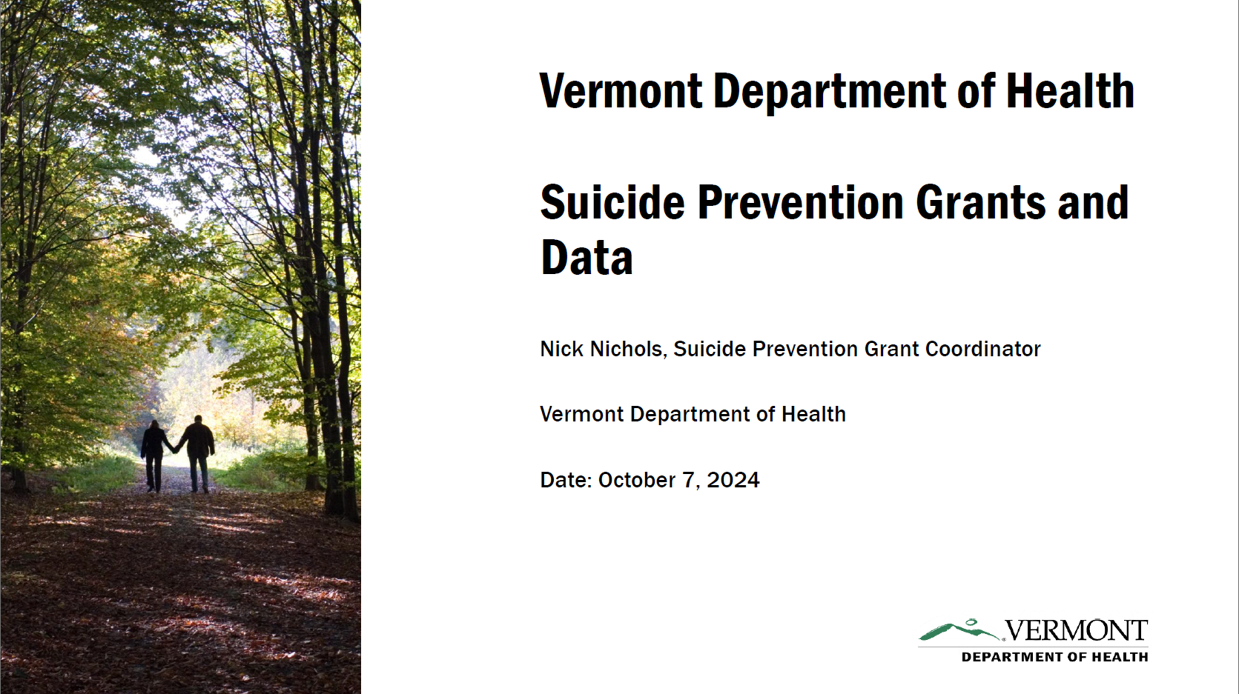
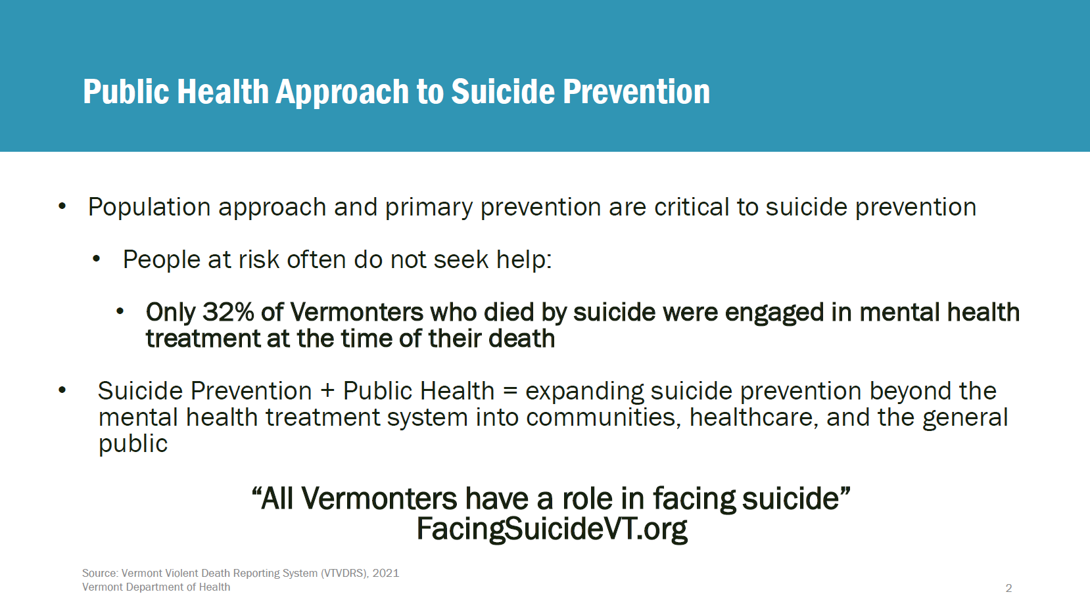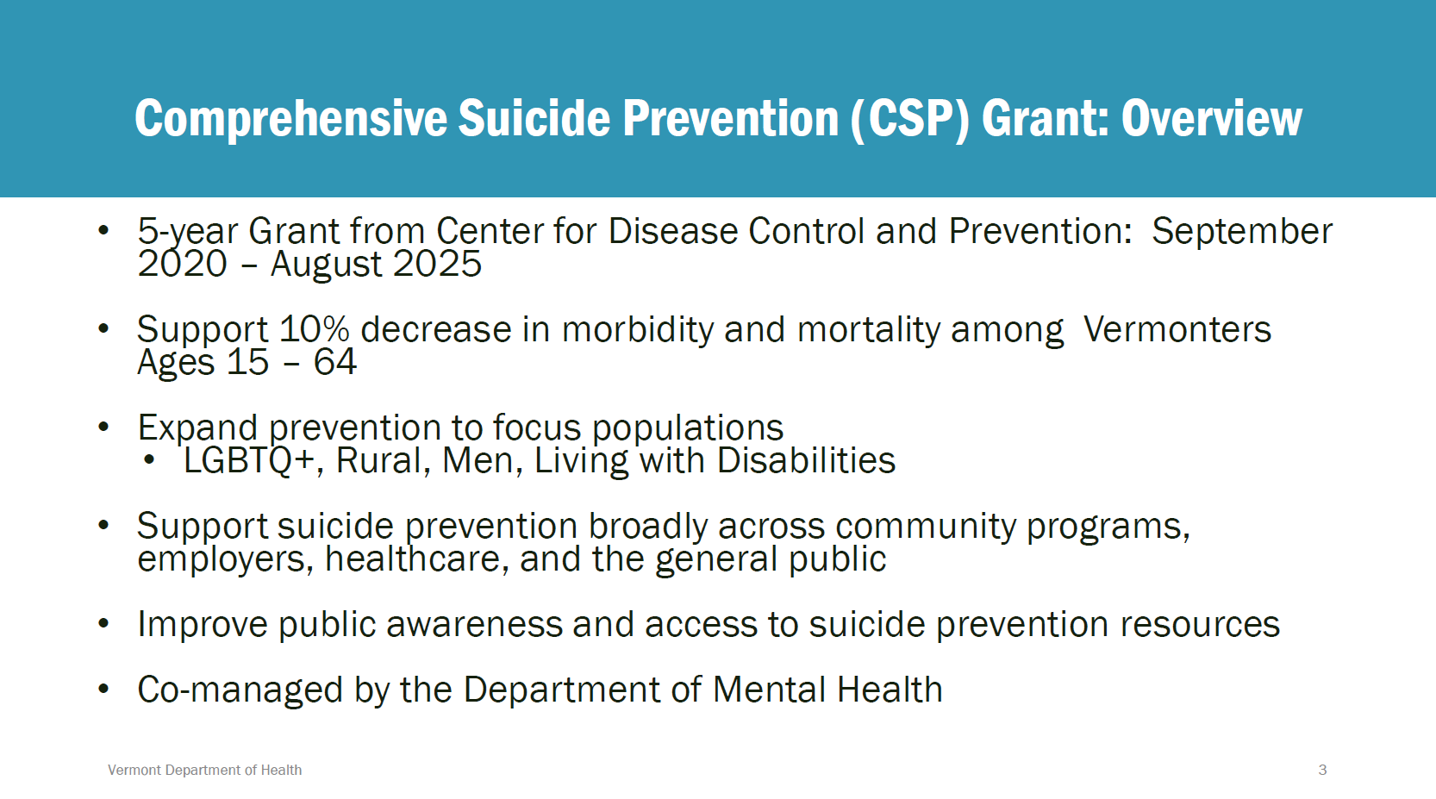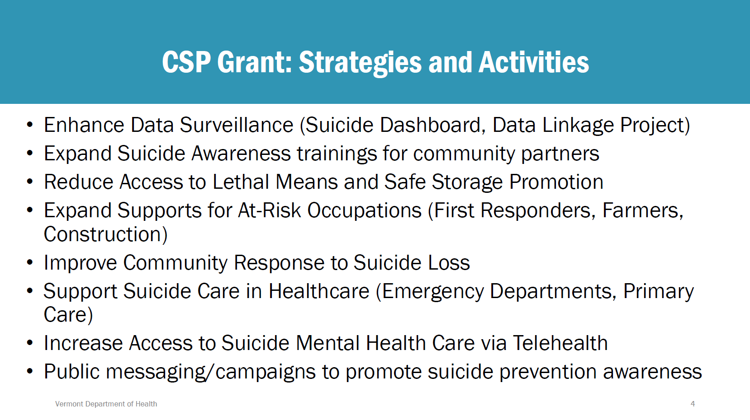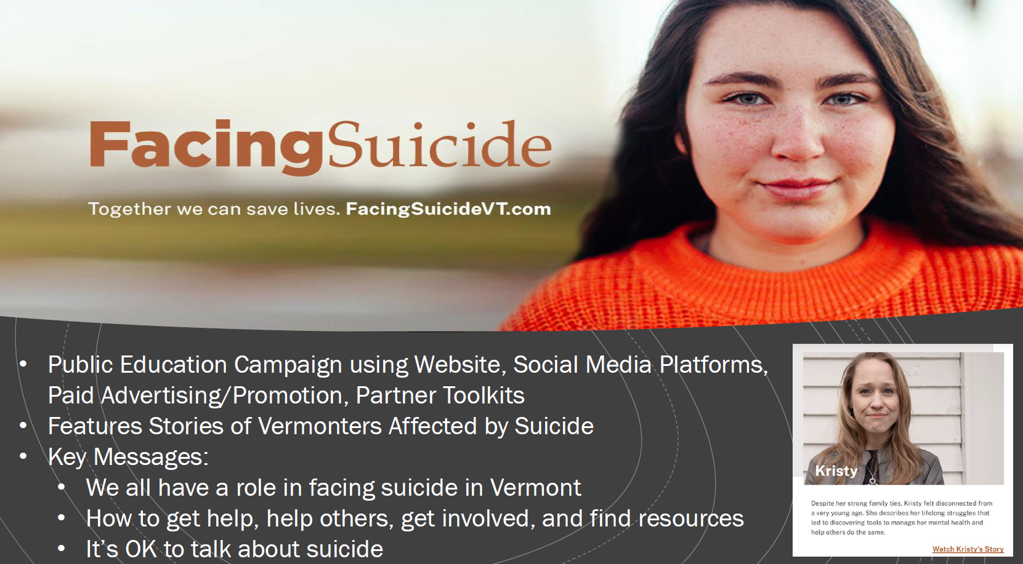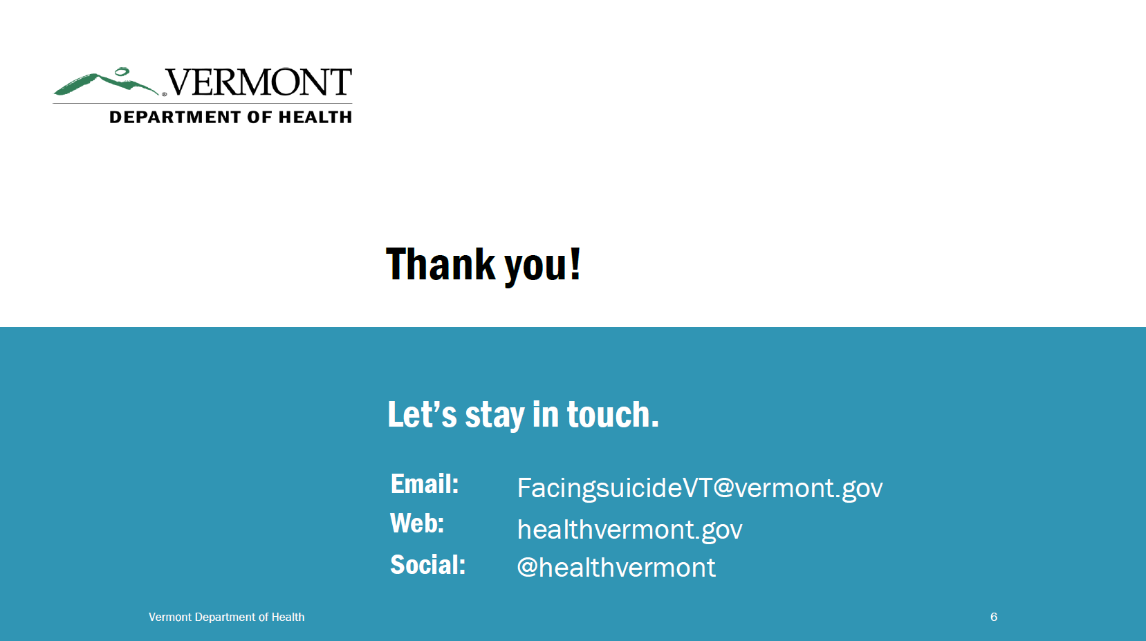
Moving CRT services from HCBS waive to State Plan funding
