10/9/2023
Adult State Program Standing Committee Minutes DRAFT

Present Members: ☐Ann Cooper (she/her)(excu) ☐ Bruce Wilson ☒Christopher Rotsettis (he/him) ☒Dan Towle (he/him) ☒Lynne Cardozo ☐ Marla Simpson (she/they)(excu) ☐Michael McAdoo(excu) ☒Zach Hughes (he/him)
DMH/State Staff: ☒Lauren Welch (she/her) ☐Eva Dayon (they/them) ☒Trish Singer ☒Katie Smith (she/her) ☒Steve DeVoe (he/him)
Public: ☐Jessica Kantatan (she/her) ☐Anne Donahue ☒Thelma Stoudt (prospective member)

Agenda
- 12:30 SPSC Business: Introductions and Review Agenda, Statement on public comment, Vote on minutes
- 1:00 Presentation: Admin Rule on Agency Designation
- 1:45 BREAK
- 2:00 Review Howard Center designation materials
- 2:40 Public Comment
- 2:50 Closing meeting business and planning next meeting agenda

Agenda Item | Discussion (follow up items in yellow)  Facilitator: Dan Towle/Zachary Hughes Timekeeper: n/a
Opening | Meeting convened at 12:38. Quorum was not met.  Announcements  - Last chance to register for the DMH Annual Conference on October 19th. There is a space to request a scholarship, making registration FREE for AMH Standing Committee members. (see image below)  - Dan will be giving two presentations. One of state of peer support work, one of peer support and mobile crisis!  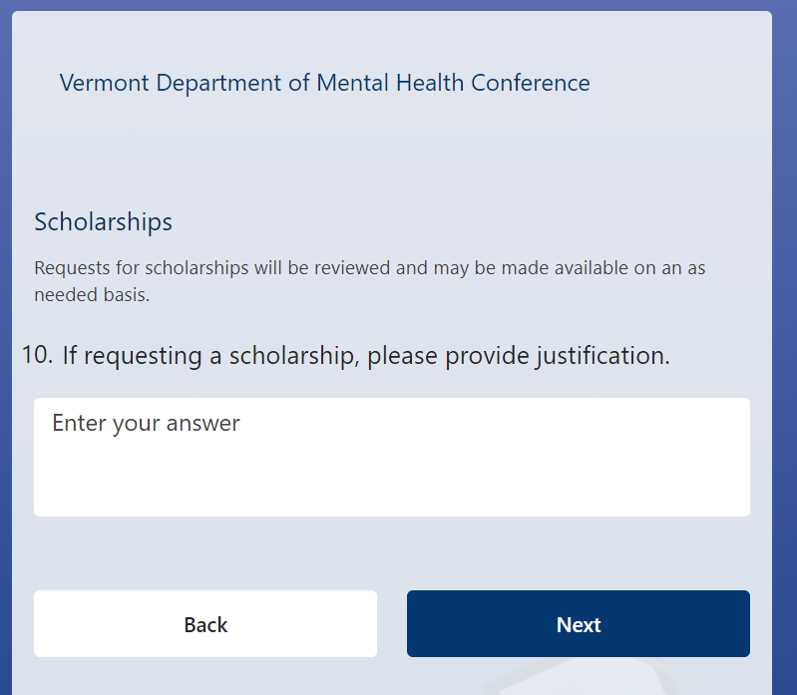  - Alyssum is looking for full- and part-time staff (particularly for the night shift).  - Friday, October 13th 11am-2pm is Alyssum’s open house. Event includes potluck, bonfire, etc  - Public Comment for UCS redesignation begins October 25th and closes November 8th.  - Vermont Psychiatric Survivors October 28th 10:30-2:00 at Rutland Free Library (with remote options)  - 10 Court Street in Rutland; Virtual Link: https://meet.google.com/mth-aqns-rtw  - NAMI Vermont Conference is coming up on November 15th in Burlington. NAMI Vermont 2023 Conference - NamiVT  Notes for follow up  - Follow-up on definition of quorum for SPSC. Is half of an even number considered a quorum? Half plus one?  - Discussion of the official policy on attendance. Is there any recourse for missing meetings written into official policy? Where is this written? Share written statement with committee.  - Add a place on the agenda for parking lot items.
Presentation: Admin Rule on Agency Designation | Lauren presented proposed updates to the Administrative Rule on Agency Designation. See attached slides.  Agency of Human Services staff also attended as support:  Steve DeVoe, DMH Director of Quality and Accountability  Seán Sheehan, AHS Administrative Services Director  Jennifer Garabedian, DAIL Development Disabilities Division Director  Comments  - Pervasive concern that simplifying admin rule on committee responsibilities will have unintended effect of pulling power away from the committee.  - Question about the definition of “mandating authority” and who is the mandating authority for this rule.  - Would like veto power written into the rule to avoid forcibly merging committees whose member do not wish to merge.  - How can a small committee continue to meet admin rule membership requirements if they do not want to merge?  - Is it true that a DA’s Board of Directors can act as its Local Program Standing Committee? Where is that written?  - Would like to see committee responsibilities written in a more active tone. Especially about hiring key management. “Recommend” sounds weak compared to the actual role of committee.  - Is the existence of the State Program Standing Committee codified by statute?  - Drop the term “client” from the membership section in favor of “lived experience.”  - Members should not be required to be or have been a DA client to participate with lived experience.  - Concluding feeling that this might be a good opportunity to evaluate the effectiveness of this committee.  - Would like meetings to be more interesting and the work more impactful.  - Conduct interviews with past members to learn why they left.  - Should attendance policy be written into statute?
Howard Center redesignation | Due to low turnout, discussion was postponed to email.  Lauren will be sure to send meeting materials with more advance to avoid issues with mail delivery.
Public Comment | Prospective member greeted members of the committee and reiterated interest in joining.
Closing Meeting Business | Recruitment  Send names and contacts for anyone who might be interested in joining to Lauren. She will reach out with an invitation.  Agenda for next meeting (November 12, 2023)  Q&A with Howard Center  Draft letter to the Commissioner  Ideas for December meeting  Review Value Based Payment data  Discuss Conflict of Interest and CCBHC  Potential visit from newly hired DMH Housing staff  Meeting adjourned 2:10PM.
Links | Register for the DMH Annual Conference: https://forms.office.com/pages/responsepage.aspx?id=O5O0IK26PEOcAnDtzHVZxntpw0yE7PlNlpO-Q1WbYIhUM1gxT1lMU1hOTFNQUUQxUlc5U1NGS1hJWC4u&wdLOR=c2776A0AA-04B1-4B6D-9F00-C0D91B024D66  Info about the NAMI Vermont Conference:  https://namivt.org/nami-vermont-2023-conference/  Virtual meeting for Vermont Psychiatric Survivors Annual Meeting on October 28th:  https://meet.google.com/mth-aqns-rtw  Interagency Committee on Administrative Rules (ICAR):  https://aoa.vermont.gov/ICAR  Legislative Committee on Administrative Rules (LCAR):  https://legislature.vermont.gov/committee/detail/2022/39  Sign up for updates from the Secretary of State:  https://secure.vermont.gov/SOS/rules/index.php  18 V.S.A. § 8733 Refers to the Advisory Board for DAIL vis-a-vis Development Disabilities Act: https://legislature.vermont.gov/statutes/section/18/204A/08733

Proposed Language (2024) | Current Administrative Rule Language (2003)
- There shall be a State Program Standing Committee (State Committee) for each population served by Designated Agencies and their families: Mental Health; and Developmental Disabilities services.  - The Advisory Board created by 18 V.S.A. § 8733 shall be the State Committee for Developmental Disabilities services. The State Committee shall comply with the requirements of that section.  - The State Committee for Mental Health shall comply with the following requirements:  - The State Committee shall be comprised of between 10 and 15 members.  - All members shall be appointed by the Commissioner or designee of DMH for terms of three years  - At least five members of the Mental Health State Committee shall be current or former disclosed adult clients of mental health services  - At least five members of the Mental Health State Committee shall be either disclosed youth clients, or family members of current or former youth clients of mental health services. | - There shall be a State Program Standing Committee (State Committee) for each DDMHS population served.  - Each State Committee shall be comprised of between 9 and 15 members, a majority of whom will be disclosed consumers and family members of the disability group that they represent.  - All members of the State Program Standing Committees shall be appointed by the Governor for staggered terms of three years and shall serve until a successor is appointed.  - An already existing statewide board or committee may serve as the State Program Standing Committee if it meets the membership requirements as stated in and performs the functions as stated.  - The Developmental Disabilities Advisory Board created by 18 V.S.A., Chapter 204A, section 8733 shall serve as the State Program Standing Committee for this population.

Proposed Language (2024) | Current Administrative Rule Language (2003)
State Committee functions shall include:  - Assisting in the identification of candidates for the State Committee;  - State Committee meeting planning and facilitation;  - Providing recommendations to the Department(s) regarding agency initial and redesignation, which may include reviewing aggregated data and reports provided by the Department.  - Ranking and recommending priority areas of focus for the statewide system of care, to be updated at least biennially. The committee will focus on these priority areas when planning agendas and engaging in work;  - Providing to the Department recommendations for candidates for classified leadership positions involved in the Agency Designation process; and  - Providing to the Department recommendations regarding new service policies or procedures, management of grievances and appeals data, or other themes identified across Agencies. | The State Committee shall advise the department on the performance of the system with respect to the points below, based on a uniform evaluative format developed by DDMHS. Responsibilities of the State Committee shall include:  - Hiring of Key Management: The Commissioner shall seek advice from the Committee in the appointment of a new Division and/or Unit director. The Division Director shall no less than annually seek feedback from the committee regarding program management.  - Evaluation of Quality: The Committee shall review information and advise the Department on the quality and responsiveness of services offered statewide.  - State System of Care Plan: The Committee shall participate in the development of the State System of Care Plan and its updates. In doing so, it will advise the Department regarding establishing general priorities for resource allocation consistent with the State System of Care Plan. Committee members will have a working knowledge of:  - Regulatory requirements or mandates that significantly influence resource allocation decisions  - Other community and departmental pressures on the resources  - Outcomes related to system of care plan priorities and general resource allocation  - Any new initiatives, demonstration projects.  - Department Policy: The Committee shall review and recommend policy that pertains to or significantly influences services for the population they represent.  - Complaints, Grievances & Appeals: The Committee shall review aggregate information on the frequency, nature and resolution of complaints about services in order to make recommendations on how the statewide network of services or Departmental operations could be improved.  - The State Program Standing Committee shall be involved in the agency designation and re-designation process, as defined in section 6 of these rules.

Link to sign up for Secretary of State updates: Vermont Secretary of State Rules Service

