11/4/2024
Adult Mental Health State Program Standing Committee Minutes
DRAFT

Attendance
Members Present: Ann Cooper (she/her), Christopher Rotsettis (he/him), Dan Towle, Michael McAdoo, Lynne Cardozo
Members Absent: Marla Simpson (she/they) (excused), Zack Hughes (he/him) (excused), Thelma Stoudt, Bruce Wilson
DMH/State Staff Present: Lauren Welch (she/her), Laura Flint (she/her), Eva Dayon (they/them), Trish Singer (she/her)
Public: Laurie Mulhern (Children’s SPSC, Mental Health Block Grant)

Agenda
- 12:30 Standing Committee Business: Introductions, Review Agenda, Statement on Public Comment, Announcements, Vote on minutes
- 1:00 Discussion: CCBHC Discretionary Items
- 1:50 Break (as needed)
- 2:00 Discussion: CCBHC Substance Use Integration
- 2:20 Discussion: CCBHC Community Needs Assessment
- 2:50 Public Comment, Closing meeting business, Plan next meeting agenda

Minutes
Follow-up items highlighted
Meeting Chair: Christopher Rotsettis

Opening Committee Business
Meeting convened at 12:32PM. Quorum was met. Reviewed agenda. Introductions.
Announcements
- Upcoming public hearings about the Admin Rule for Peer Certification. November 14th and 15th, on Teams or in-person in Montpelier
  - You may attend the public hearings in person or via Teams. Both meetings will be held at the Office of Professional Regulation, on the 3rd floor of 89 Main Street, Montpelier (City Center).
    - Thursday, November 14th from 6:00PM-8:00PM
      - Teams: Join the meeting now
Meeting ID: 213 506 890 763
Passcode: GCm9mv
Dial in by phone: +1 802-828-7667
Phone conference ID: 778 790 493#
    - Friday, November 15th from 2:30PM-4:30PM
      - Teams: Join the meeting now
Meeting ID: 296 967 179 457
Passcode: RKhv3t
Dial in by phone: +1 802-828-7667
Phone conference ID: 956 630 913#
Discussion: Timing of Public Comment during Standing Committee meetings
- Should Public Comment be moved to directly after the break? Keep at the end of the meeting? Or add an additional designated public comment time after the break?
- Public comment would be valuable after each agenda item and before the committee takes a vote.
- Only having public comment at the end sends the message that public comment is an afterthought.
- Should we add public comment during agenda review for members of the public to add items to the agenda? Rather than adding to the agenda, just ask for members of the public to identify if they intend to speak during public comment.
- Sounds like consensus reached to do the following:
  - Edit statement on public comment to request public identify if they are hoping to speak.
  - Add public comment prompt directly after the break.
  - Save some time at the end of meeting for any wrap-up public comment.
Previous Meeting Minutes
Proposed edits:
- Move announcement about NAMI conference to appendix. Only include things that were actually said in the meeting.
Ann motioned to accept October 2024 meeting minutes with edits. Dan seconded. All in favor. October minutes were accepted with edits.

Discussion: CCBHC Discretionary Items
Slides included in minutes appendix.
Eva Dayon, DMH Assistant Director of Quality (eva.dayon@vermont.gov)
How did Vermont get from having 4-5 designated agencies with planning grants to having only 2 agencies receiving certification?
  - Planning grant process and certification are two different processes.
  - The planning grants were awarded directly from the federal government.
  - CCBHCs can only be certified by the State to receive enhanced funding.
  - The State decided to pursue two certifications at a time, so the State selected the two agencies that were most ready for certification.
Discretionary items – States can require more stringent criteria than SAMHSA does, but they cannot require less stringent criteria.
- Medical director must be a physician because DMH has found discrepancy in quality of medication management services when medical director is a Nurse Practitioner or Advanced Practice Nurse.
  - The federal criteria also require the medical director be in person at least once a week.
- Geographic boundaries for CCBHC. Clients have historically opted to travel outside their geographic area if they know they can receive better services elsewhere.
  - People who work for a designated agency or CCBHC should have the right to receive services of their own somewhere they don’t work.
- Incentivizing inpatient facilities for smooth transition to community. DMH already tracks how long someone stays inpatient after they no longer meet criteria for that level of care. The current benchmark is 3 days.
- Committee recommends any use of the term “behavioral health” be written in quotes whenever the term is included in presentations.
- License requirements for conducting clinical evaluations. Certified Peer Support workers are not considered licensed health professionals according to Department of Vermont Health Access regulations. Licensing adds a level of supervision, training, and billing that are not applicable to Peer Support workers.
  - Committee member asked that this decision be reviewed again.
- Required screening tools. The state will only require CANS and ANSA, but agencies tend to use a kitchen sink of screening tools at their own discretion.
  - Eating disorders are prevalent in Vermont, so should the state require eating disorder screenings?
- Evidence-Based Practices. In addition to the 9 practices listed on the slide, DMH will also require Motivational Interviewing (particularly for Substance Use)
  - Should Vermont require WRAP (Wellness Recovery Action Plan) as an evidence-based practice? What about the NAMI Family-to-Family model?
    - Vermont CCBHCs recognize that they will need support in standing up family peer supports.
  - This criterion speaks to the baseline evidence-based practices required, but it does not preclude agencies from using additional evidence-based practices.
- Required partnerships. Anything additional?
  - Recovery centers?
  - Is the requirement for partnership with Pathways only apply to Housing First? This isn’t clear at the moment, but CCBHCs should, at minimum, partner with Housing First.
  - Homelessness agencies should be explicitly included in the list of partnerships rather than languishing in the “other” category.
  - Communication support specialists? Vermont Communication Support Project.
- Required aspects of Treatment Planning
  - The additional items suggested by SAMHSA are already being done by agencies without having to explicitly require them.
  - Committee thinks peer support services should be explicitly included in the treatment planning process.
Committee entered BREAK at 1:50PM.
Committee reconvened at 2:00PM.

Public Comment
Member of the public sent question to Eva via email requesting further information about interim Medical Director criteria.
- Eva’s response in-meeting: DMH will review and approve corrective action plans for designated agencies to fill the Medical Director role, but DMH is still discussing how the general corrective action process will proceed under CCBHC.
- SAMHSA project officers are not providing clear guidance about corrective action because they have to hold the line that CCBHCs need to meet 100% criteria for certification despite knowing this is not practical.

Discussion: CCBHC Substance Use Integration
Slides included in minutes appendix.
Eva Dayon, DMH Assistant Director of Quality (eva.dayon@vermont.gov)
In general, DMH is raising standards to meet the more stringent standards of Vermont Department of Health Division of Substance Use.

Discussion: CCBHC Community Needs Assessment
Slides included in minutes appendix.
Laura Flint, CCBHC State Planning Grant Project Director (laura.flint@vermont.gov)
A community needs assessment is used to determine what the local needs of the CCBHC are as well as to identify populations that have not been served (and what needs to be done to improve access to services)
The State has not yet decided if it will require CCBHCs to use a specific community needs assessment template.
- Comment in the chat: a template should be used; otherwise, there is no consistency when comparing data, or using the data to drive decisions.
- Template is not necessarily designed to perform statewide analyses. But, the State is discussing the potential for a state-level needs assessment to take some of the burden off of the local providers if there are key issues that apply across the state.
- Statewide analysis would require there to be both a standard template as well as standard data collection processes.
- The main intention of the community needs assessment template is to guide applicant agencies to meet all the requirements specified in the CCBHC criteria.
- Dartmouth-Hitchcock gave a presentation at an Equity Summit a few weeks ago about effective community needs assessments. One of their recommendations was to leverage existing assessments to prevent survey fatigue and limit administrative burden.
- Surveys are distributed at the local level, so there isn’t a standard accessibility practice for surveys. Is there a way to ensure that agencies are using accessible surveys? Lynne is a good resource for future discussions on this topic.
  - Also consult the Language Justice Project to generate/review surveys in other languages.

Public Comment
There is an issue of engagement with surveys. Reach out to folks where they already are: local WICK office, hospitals/clinics, schools, social media, etc

Closing Meeting Business
Debrief NAMI VT Conference
David Melnick from NFI (Northeastern Family Institute) about Trauma Transformed care. Highly recommend hearing David Melnick speak if given the chance.
Next Meeting: December 9th
- Reinvite Nick Nichols and Chris Allen to talk about winding down of the grant.
- Grievances and Appeals data report; Send data prior to meeting!!
- Discuss meeting lineup for 2025
- Discuss moving meetings to the first Monday of the month going forward? What’s the best and time.
- Touch base on membership.
As yet unscheduled:
- Leadership Update: Peer Certification
  - Trish Singer, Mental Health Operations Director
- Age Strong Vermont; hear from Director of Adult Services at DAIL
- Leadership Update
  - Emily Hawes, DMH Commissioner
- Peer respite – Will Everly from Alyssum
- Mad Freedom – Chris Niall
Meeting adjourned 3:07PM.

Appendix

Additional Announcements
Further info about Peer Certification Public Comment
The public comment period has opened for the Office of Professional Regulation’s Proposed Administrative Rule for Peer Support Provider Certification and Peer Recovery Support Specialist Certification.
Stakeholder guidance in the initial drafting of the rule was invaluable, and the Department of Mental Health and OPR would like to invite you to comment on the rule in its proposed form, and/or to attend the public hearings scheduled for November 14th and 15th on Teams or in person in Montpelier.
The current draft of the Rule can be found here for your review: Alfresco » Peer Support Provider and Peer Recovery Support Specialist Draft Rules (state.vt.us)
Public Comments
Written comments can be submitted via email or by mail. All submitted comments are public record, and all comments or comment summaries and responses will be included in the next filing of the Rule. Please consider including contact information with your comment, in case the Office of Professional Regulation needs to contact you for further information.
To submit comments via email, please send them to sos.opr.comments@vermont.gov.
To submit comments via mail, please mail them to:
Public Hearing: Peer Support Provider & Recovery Support Specialists
Vermont Office of the Secretary of State, Office of Professional Regulation
89 Main Street, 3rd Floor Montpelier
Vermont 05602
Public Hearings
If you would like to comment in the public hearing, it is helpful if you also write your comment down or write a summary of your comment and submit it via email, post, or in person at the meeting. Because hearings are recorded and oral comments can be reviewed later, this is not required, but it helps to ensure that your comment is captured accurately and in its entirety.
You may attend the public hearings in person or via Teams. Both meetings will be held at the Office of Professional Regulation, on the 3rd floor of 89 Main Street, Montpelier (City Center).
Thursday, November 14th from 6:00PM-8:00PM
Teams: Join the meeting now
Meeting ID: 213 506 890 763
Passcode: GCm9mv
Dial in by phone: +1 802-828-7667
Phone conference ID: 778 790 493#
Friday, November 15th from 2:30PM-4:30PM
Teams: Join the meeting now
Meeting ID: 296 967 179 457
Passcode: RKhv3t
Dial in by phone: +1 802-828-7667
Phone conference ID: 956 630 913#
Thank you for your valuable input as DMH and OPR continue to collaborate on this rule. Your insights are greatly appreciated. Looking forward to your continued collaboration!

Links
- Admin Rule for Peer Certification: https://cms.sec.state.vt.us:8443/share/s/DFzlQlO1TqOga9GUg6W3Eg
- Links on CCBHC slides are copied out below each slide.

Parking Lot
- Age Strong Vermont; hear from Director of Adult Services at DAIL
- Update on the opioid crisis in Vermont. Substance abuse and quality of life (especially since the pandemic)
- Should we be clearer about how many people to invite to designation visits?

Presentation Slides
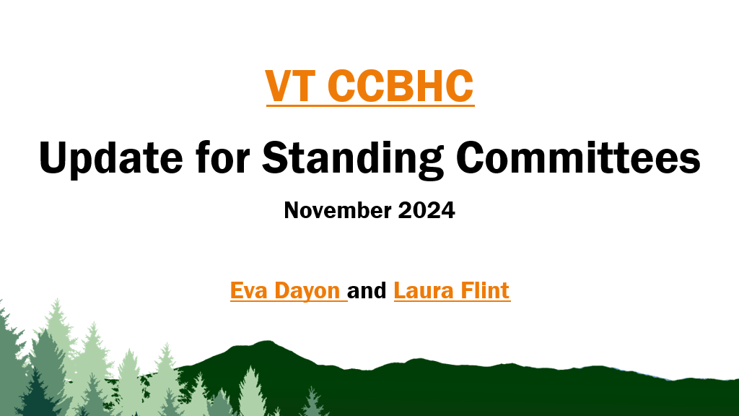
VT CCBHC https://mentalhealth.vermont.gov/about-us/department-initiatives/ccbhc 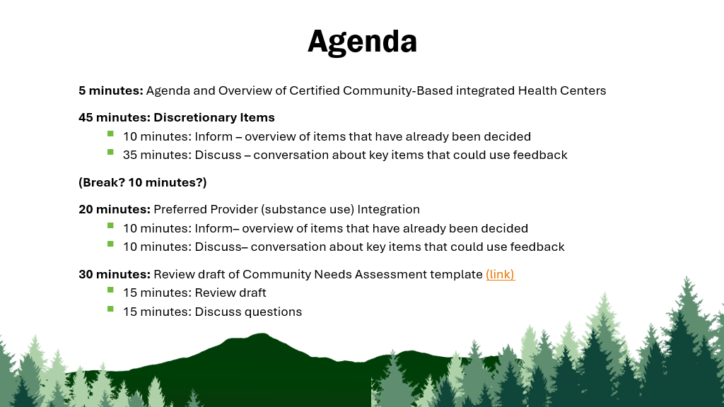
Community Needs Assessment template https://mentalhealth.vermont.gov/document/draft-vt-ccbhc-cna-guide-sept-2024 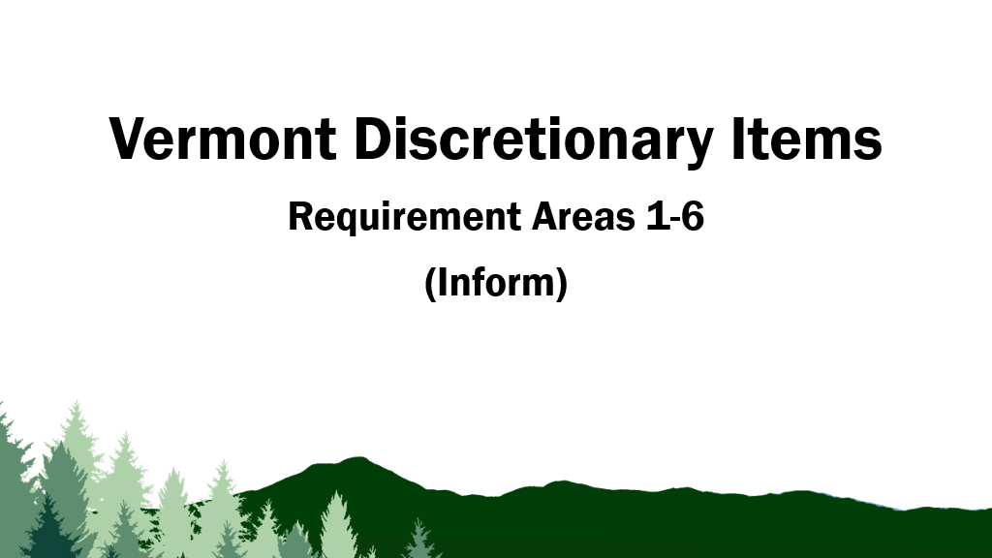 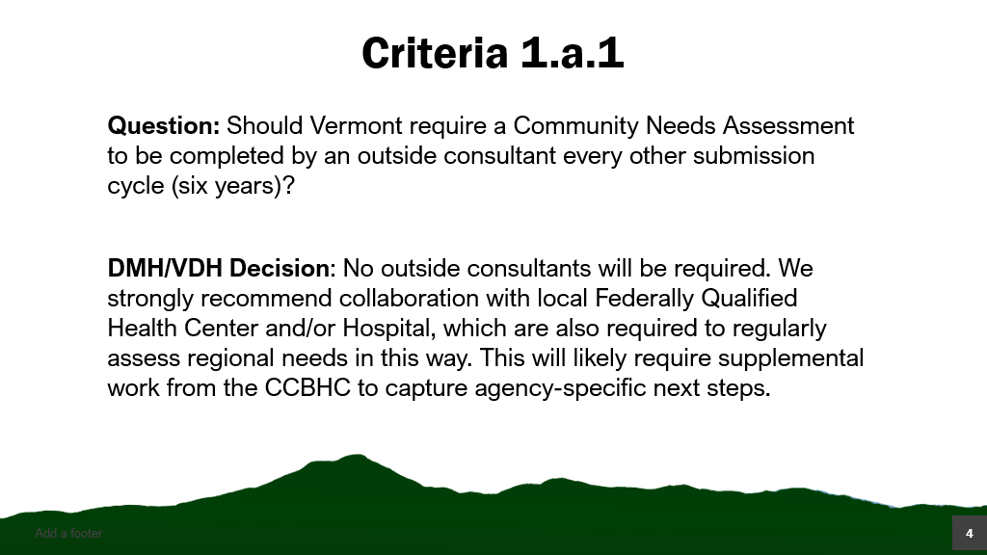 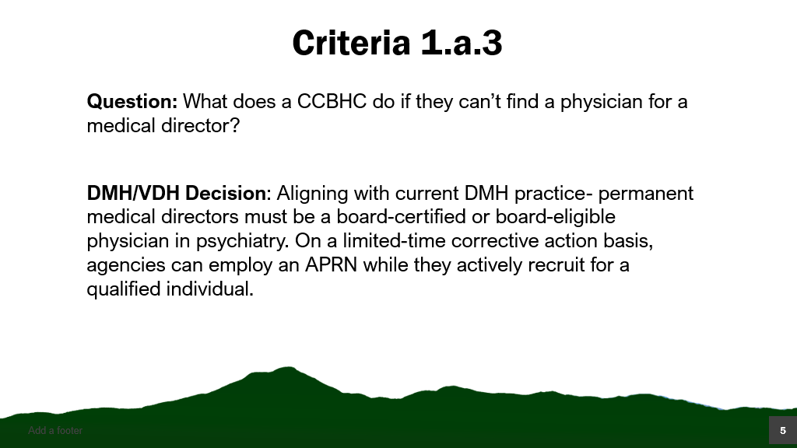 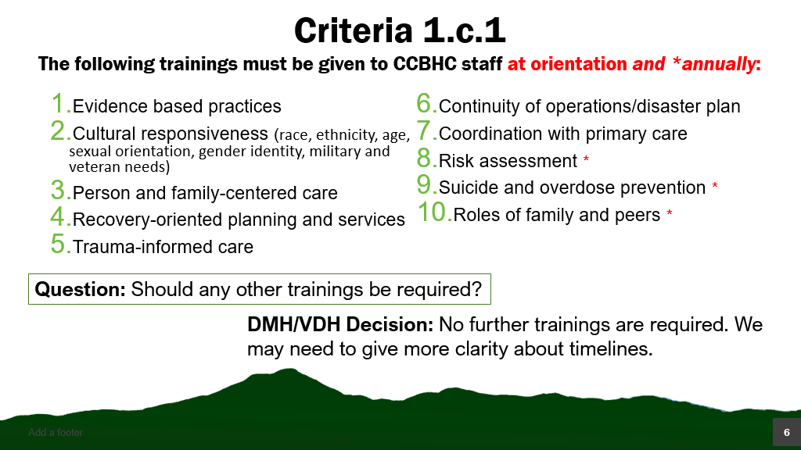 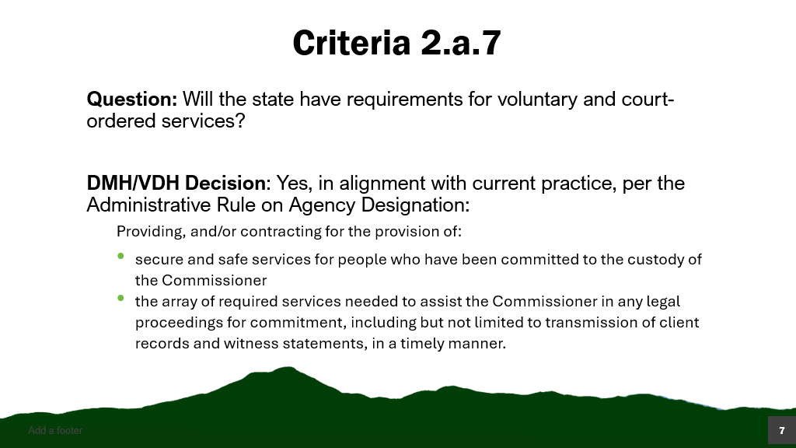 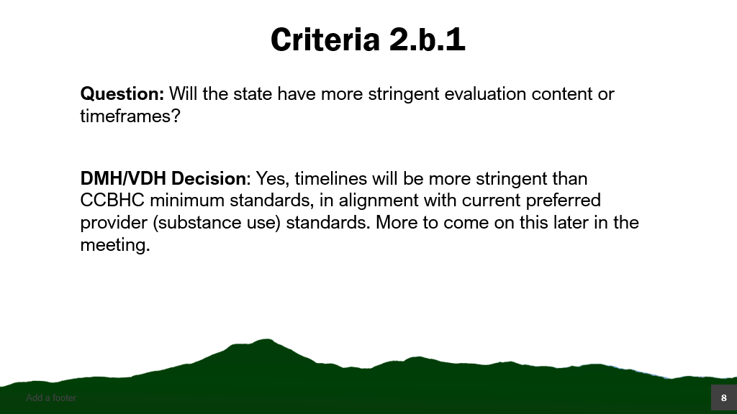 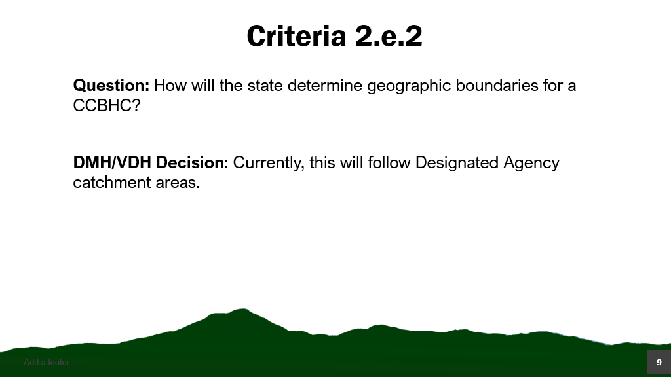 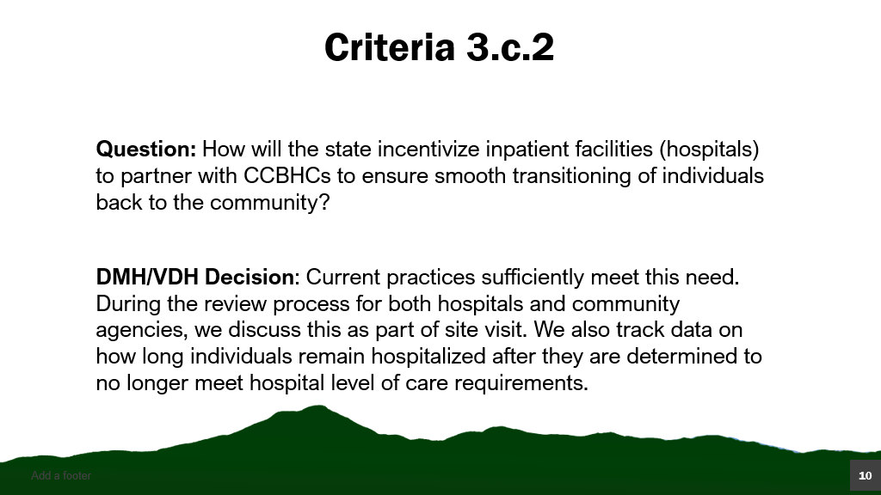 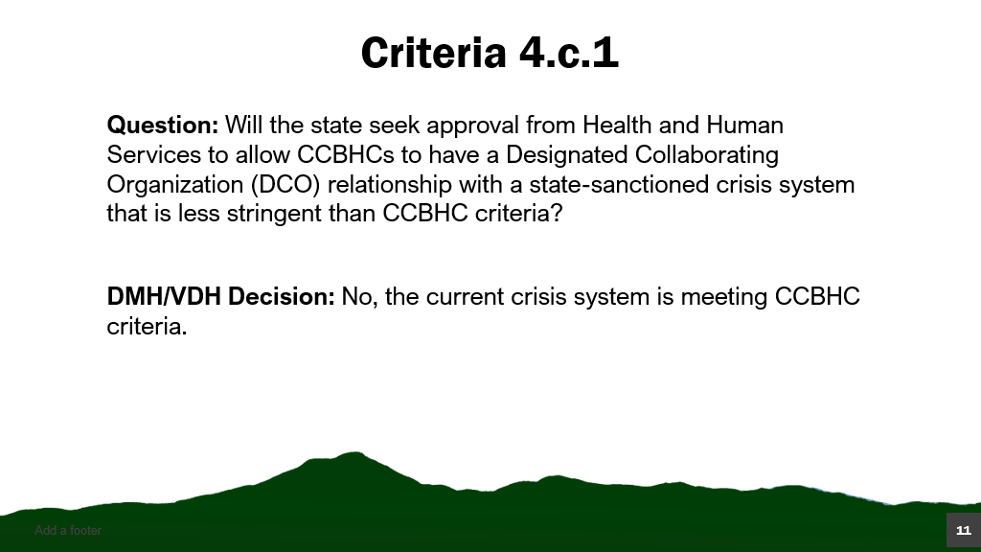 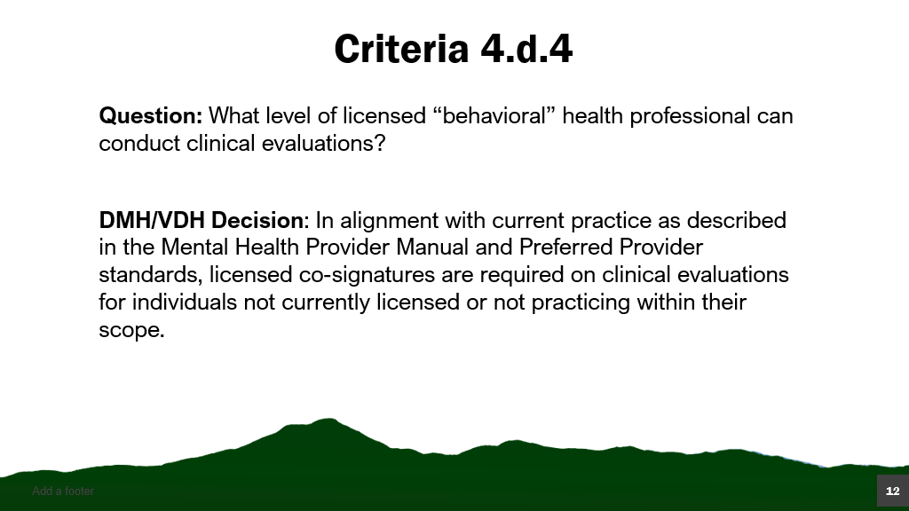 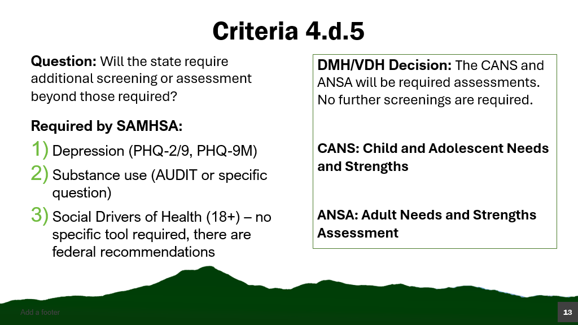 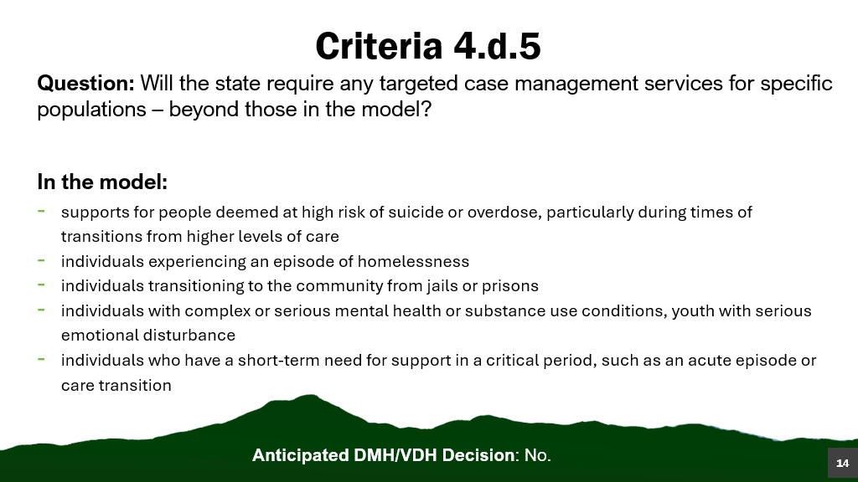 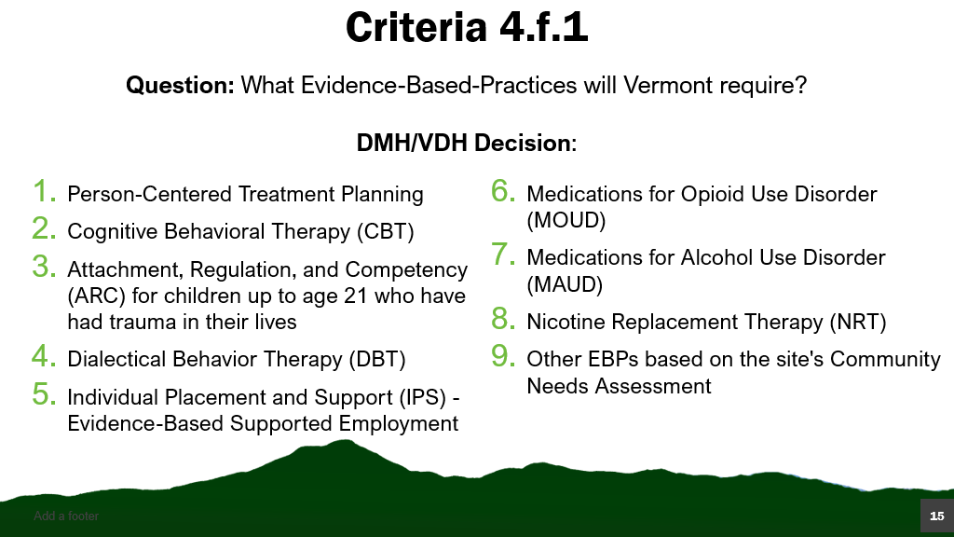 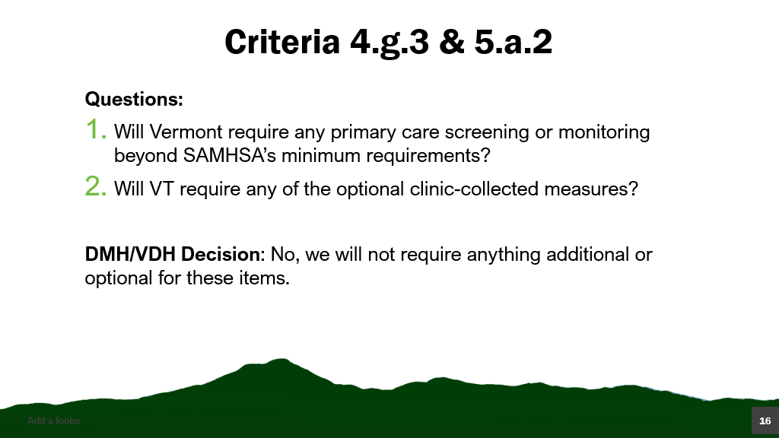 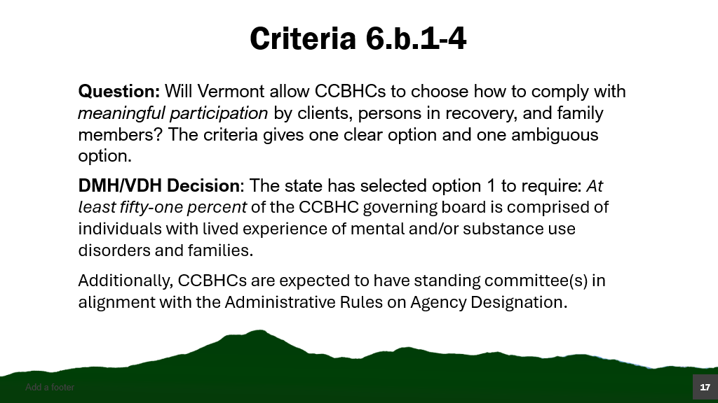 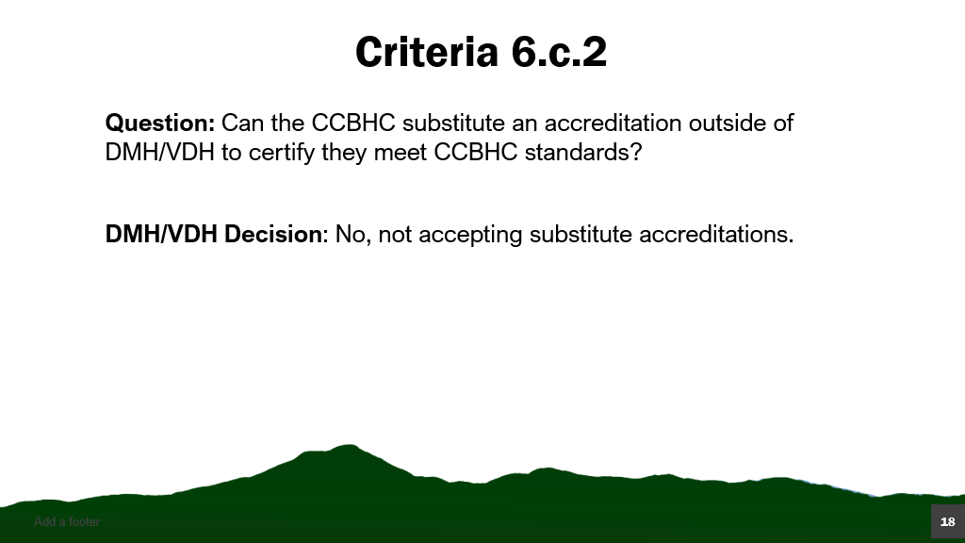 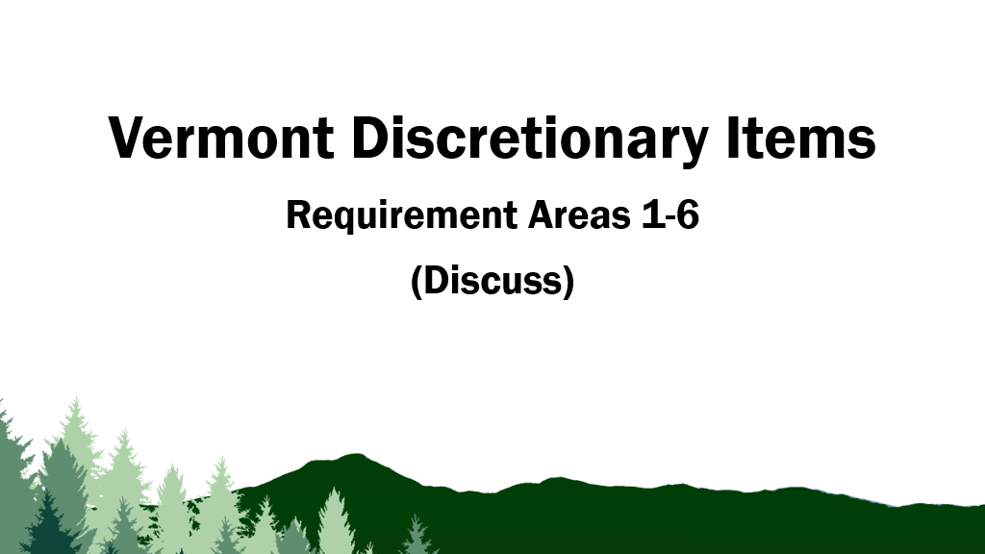 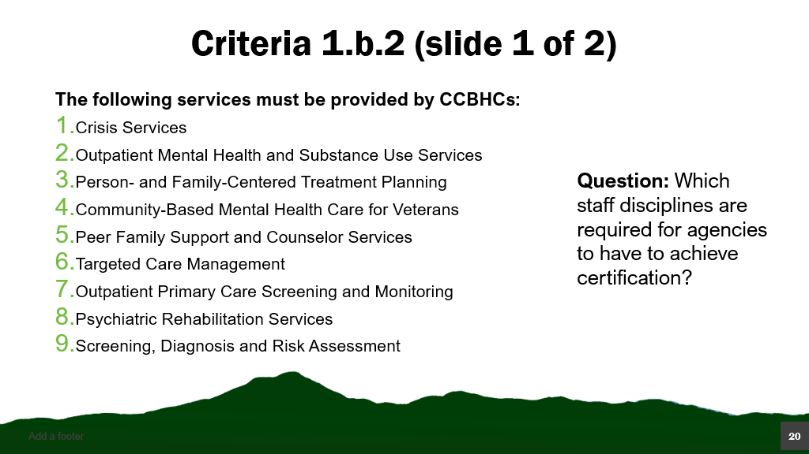 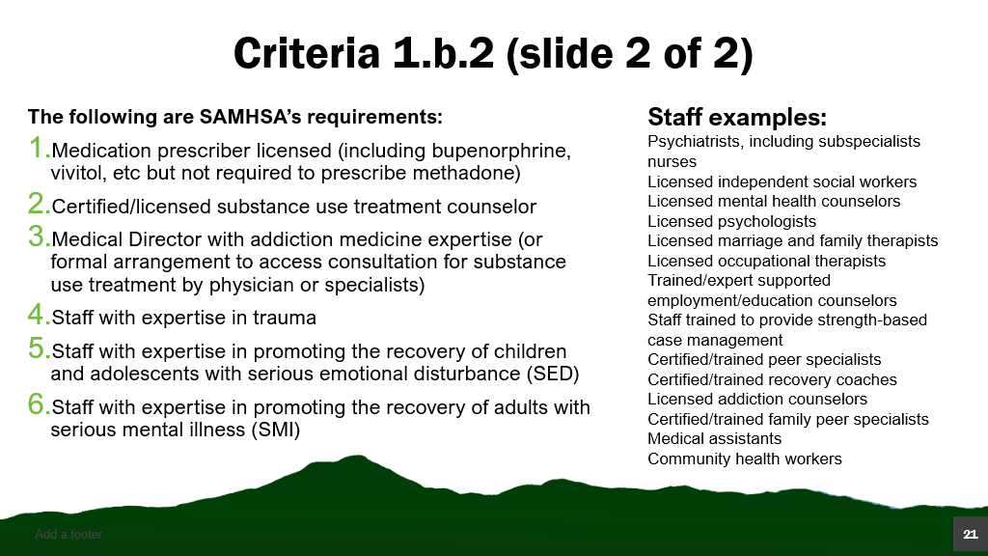 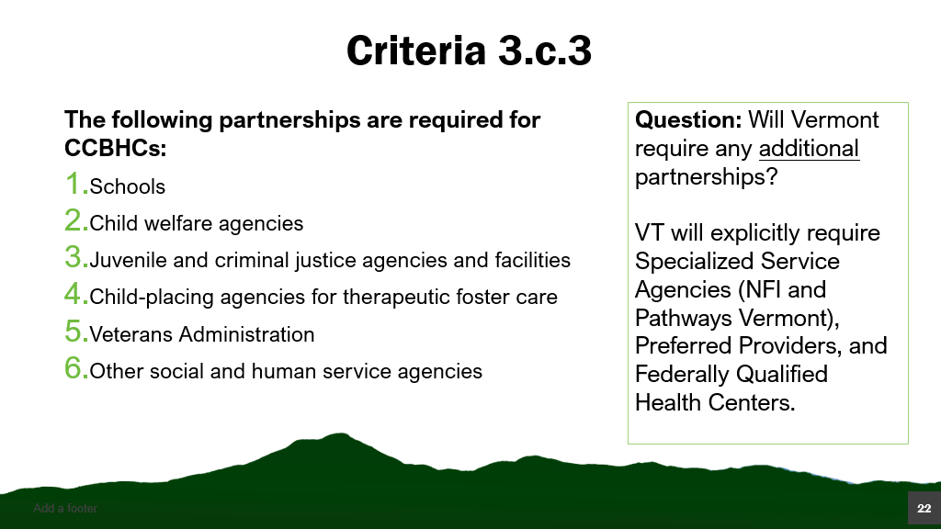 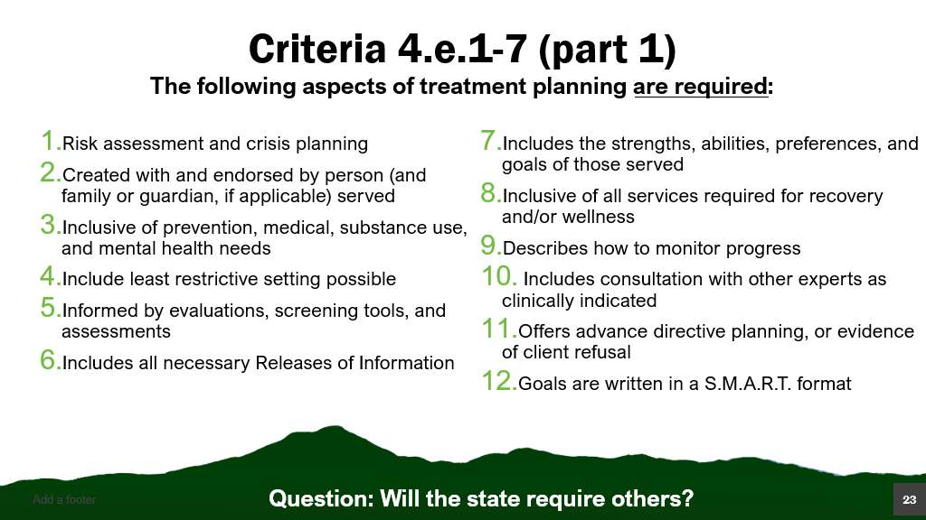 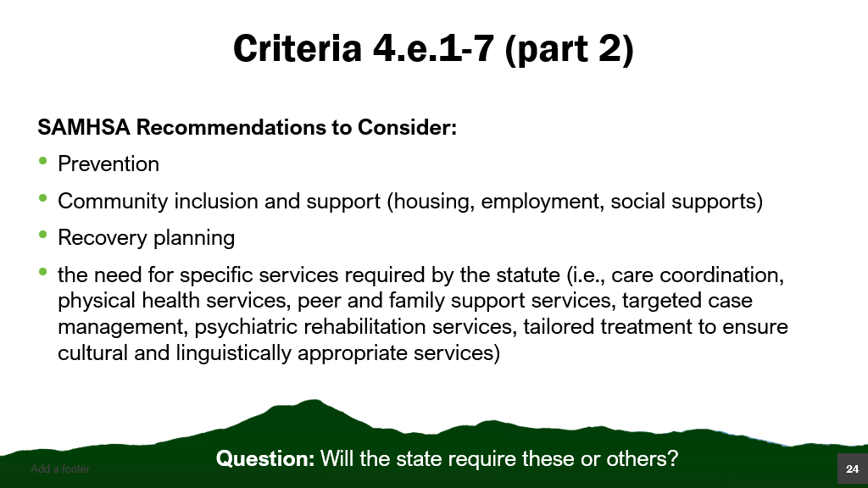 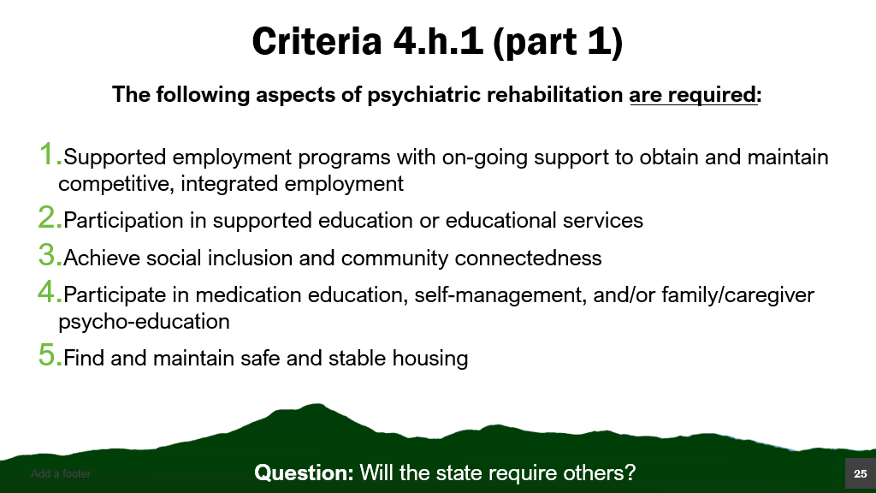 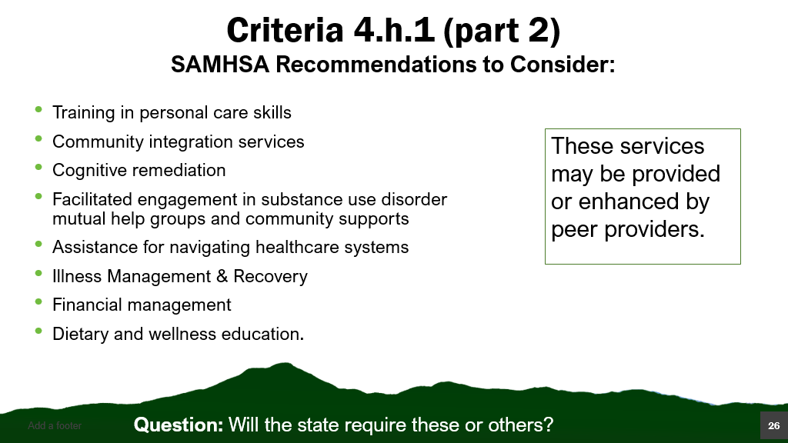 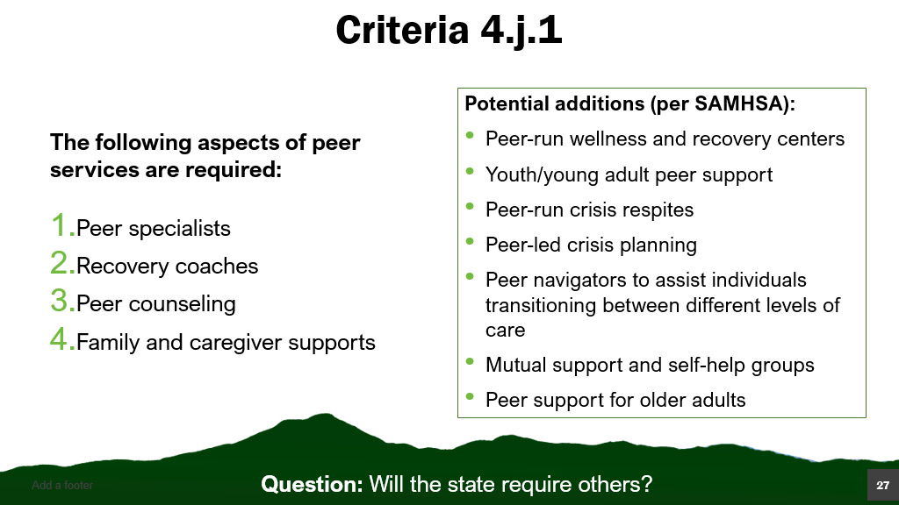 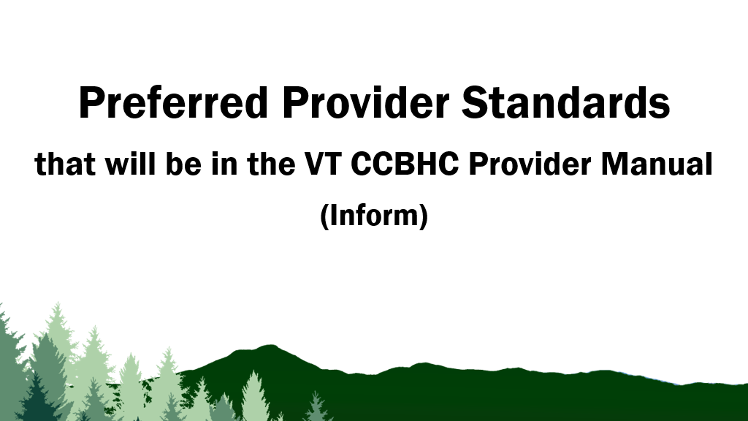 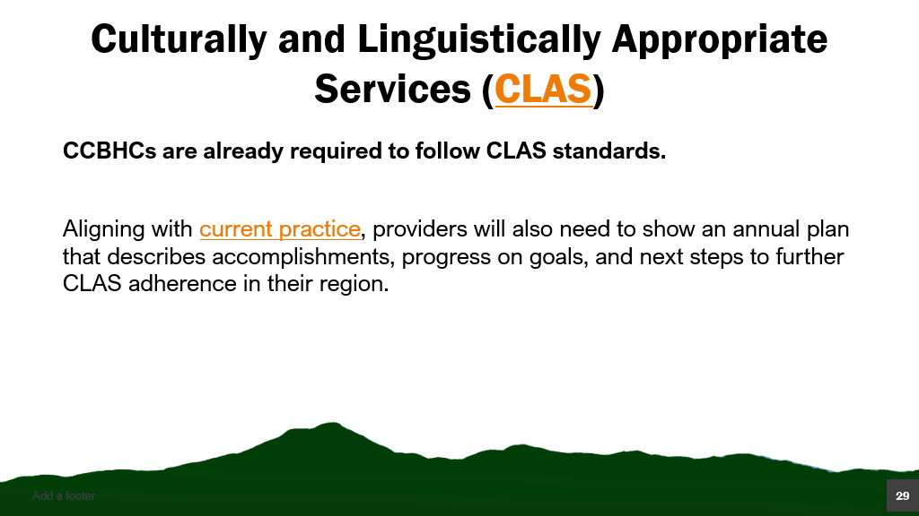
CLAS https://thinkculturalhealth.hhs.gov/clas
Current Practice https://www.healthvermont.gov/sites/default/files/document/dsu-treatment-standards.pdf
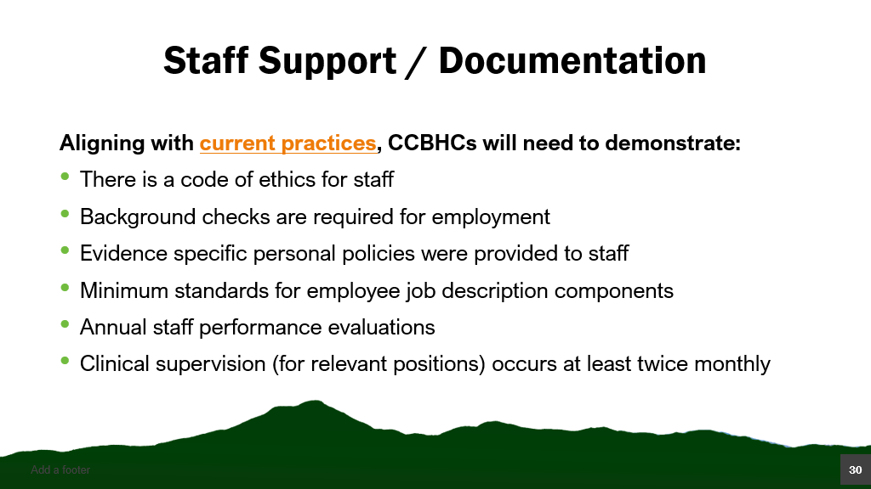
Current Practices https://www.healthvermont.gov/sites/default/files/document/dsu-treatment-standards.pdf
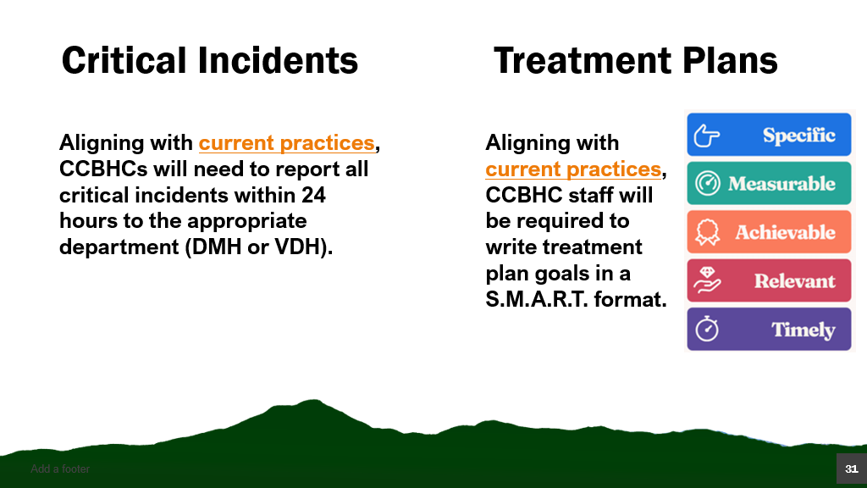
Current Practices https://www.healthvermont.gov/sites/default/files/document/dsu-treatment-standards.pdf
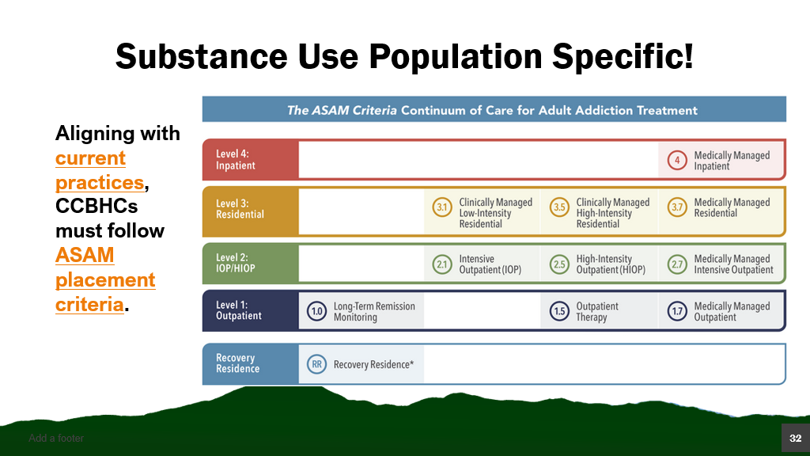
Current Practices https://www.healthvermont.gov/sites/default/files/document/dsu-treatment-standards.pdf
ASAM Placement Criteria https://www.asam.org/asam-criteria/about-the-asam-criteria 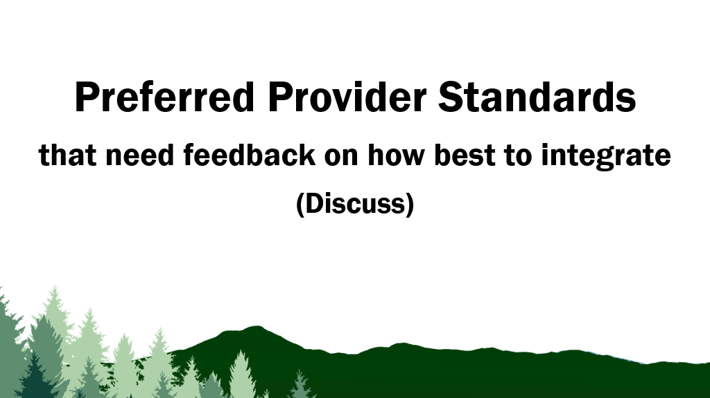 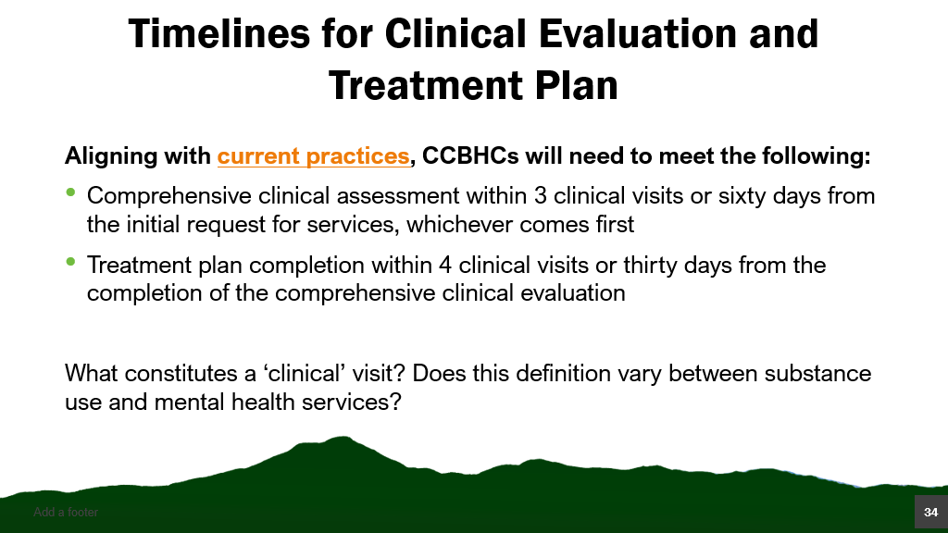
Current Practices https://www.healthvermont.gov/sites/default/files/document/dsu-treatment-standards.pdf
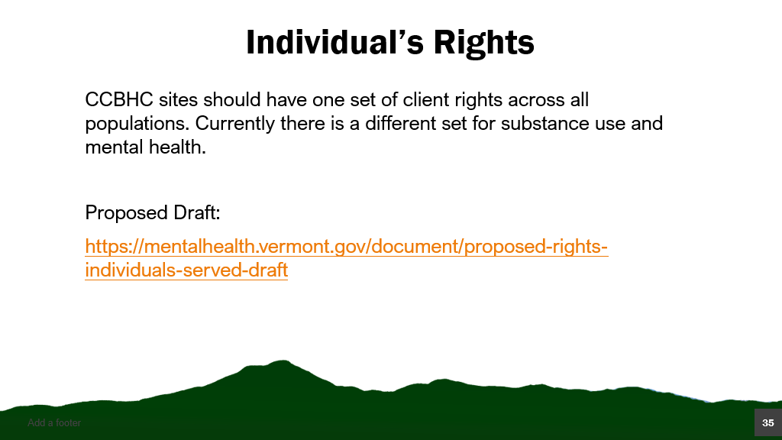
Individual Rights Proposed Draft https://mentalhealth.vermont.gov/document/proposed-rights-individuals-served-draft 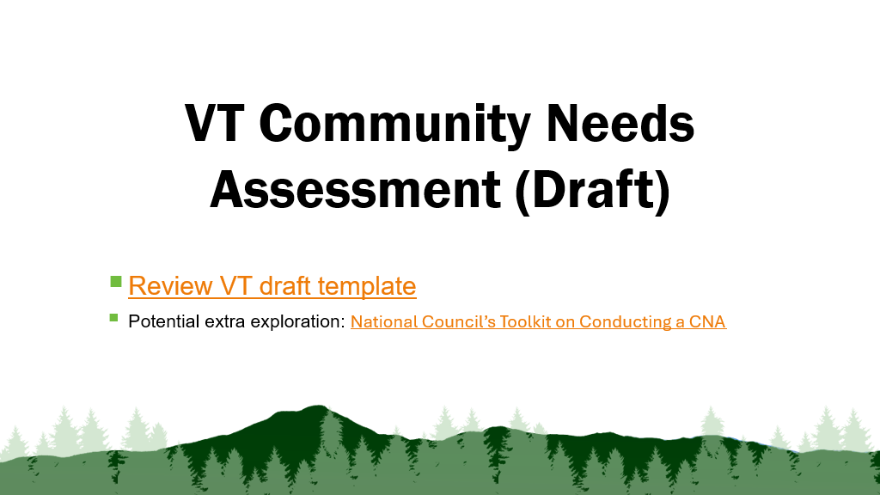
Review VT draft template https://mentalhealth.vermont.gov/document/draft-vt-ccbhc-cna-guide-sept-2024
National Council’s Toolkit on Conducting a CAN https://www.thenationalcouncil.org/resources/ccbhc-community-needs-assessment-toolkit/
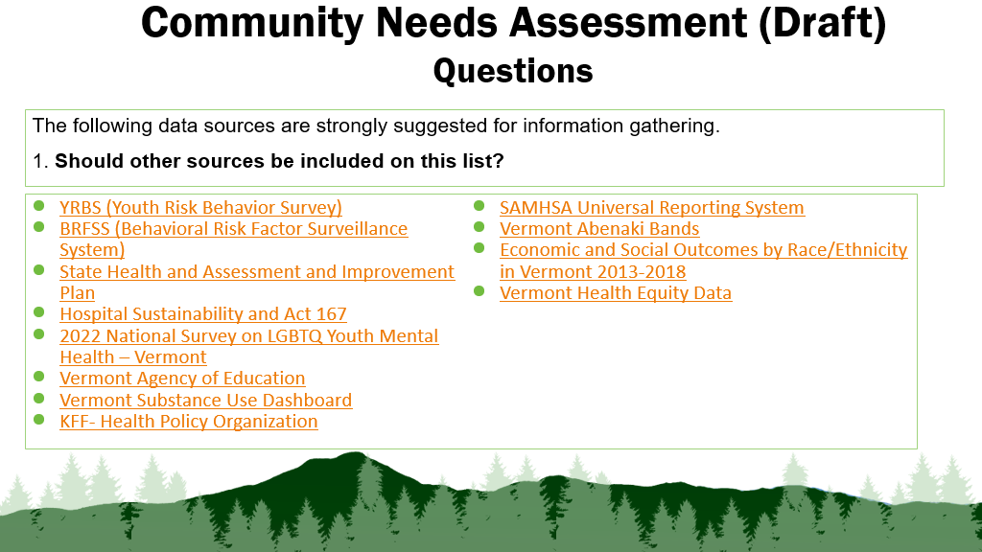
- YRBS (Youth Risk Behavior Survey)​ https://www.healthvermont.gov/stats/population-health-surveys-data/youth-risk-behavior-survey-yrbs
- BRFSS (Behavioral Risk Factor Surveillance System) ​ https://www.healthvermont.gov/stats/population-health-surveys-data/behavioral-risk-factor-surveillance-system-brfss
- State Health and Assessment and Improvement Plan ​ https://www.healthvermont.gov/about/plans-reports/state-health-assessment-and-improvement-plan
- Hospital Sustainability and Act 167 ​ https://gmcboard.vermont.gov/Act-167-Community-Meetings
- 2022 National Survey on LGBTQ Youth Mental Health – Vermont ​ https://www.thetrevorproject.org/wp-content/uploads/2022/12/The-Trevor-Project-2022-National-Survey-on-LGBTQ-Youth-Mental-Health-by-State-Vermont.pdf
- Vermont Agency of Education ​ https://education.vermont.gov/data-and-reporting
- Vermont Substance Use Dashboard​ https://www.healthvermont.gov/alcohol-drugs/substance-use-data-reports/substance-use-dashboard
- KFF- Health Policy Organization​ https://www.kff.org/statedata/mental-health-and-substance-use-state-fact-sheets/vermont/
- SAMHSA Universal Reporting System​ https://www.samhsa.gov/data/data-we-collect/urs-uniform-reporting-system
- Vermont Abenaki Bands ​ https://vcnaa.vermont.gov/cultural-resources
- Economic and Social Outcomes by Race/Ethnicity in Vermont 2013-2018 ​ https://legislature.vermont.gov/Documents/2022/WorkGroups/Senate%20Government%20Operations/Reports%20and%20Resources/W~Agency%20of%20Human%20Resources~REAP%20Economic%20and%20Social%20Data%20by%20Race~1-14-2021.pdf
- Vermont Health Equity Data https://www.healthvermont.gov/stats/surveillance-reporting-topic/health-equity-data
