1/8/2024
Adult State Program Standing Committee Minutes DRAFT

Present Members: ☒Ann Cooper (she/her) ☒ Bruce Wilson ☐Christopher Rotsettis (he/him) (excu) ☐Dan Towle (he/him) (excu)☒Lynne Cardozo ☒Marla Simpson (she/they) ☒Michael McAdoo ☒Thelma Stoudt ☐Zach Hughes (he/him) (excu)
DMH/State Staff: ☒Lauren Welch (she/her) ☒Eva Dayon (they/them) ☐Trish Singer ☐Katie Smith (she/her) ☒Chris Allen (he/him)
Public: ☐Jessica Kantatan (she/her) ☐Anne Donahue

Agenda
- 12:30 SPSC Business: Introductions and Review Agenda, Statement on public comment,
- 12:35 Update: Suicide Prevention Strategic Plan
- 1:00 Announcements, Vote on minutes
- 1:30 BREAK
- 1:40 Presentation: Value Based Payment
- 2:10 Discussion: Adult SPSC 2024 Top Priorities
- 2:40 Public Comment
- 2:45 Closing meeting business and planning next meeting agenda

Agenda Item | Discussion (follow up items in yellow)  Facilitator: Ann Cooper
Opening Committee Business | Meeting convened at 12:33. Quorum was met. Introductions were made.
Update: Suicide Prevention Strategic Plan | Chris Allen (he/him), DMH Director of Suicide Prevention (christopher.m.allen@vermont.gov)  - Role and responsibility to develop Strategic Plan established by Act 56 passed in 2023 legislative session  - Steering committee meeting biweekly since august (composed of 8 people)  - Advisory group has had a few meetings in the fall and plans to have another in winter/spring to discuss final draft of Plan (between 20-30 people)  - Strategic Plan is due in July 2024  - Public listening sessions were held in late October 2023 (attended by 8-15 people)  - February 2024 listening session will focus on kids (Including transition-aged youth)  - Sounds like listening sessions were not advertised widely enough  - Distributed via several listservs including the Center for Health and Learning and the American Foundation for Suicide Prevention. Between these two lists, there are close to 1000 members.  - There were also QR codes posted at several in-person events in fall 2023  - Would like to see DMH work to advertise to people who are not part of “the work” but rather people with lived experience  - Conversation was still fruitful and attendees were not members of the steering committee or advisory group.  - SWOT analysis was performed and then applied to a TOWS framework to identify threats and opportunities to suicide prevention efforts. Facilitated by the State Continuous Improvement Network  - More info on SWOT/TOWS: MindTools | Home  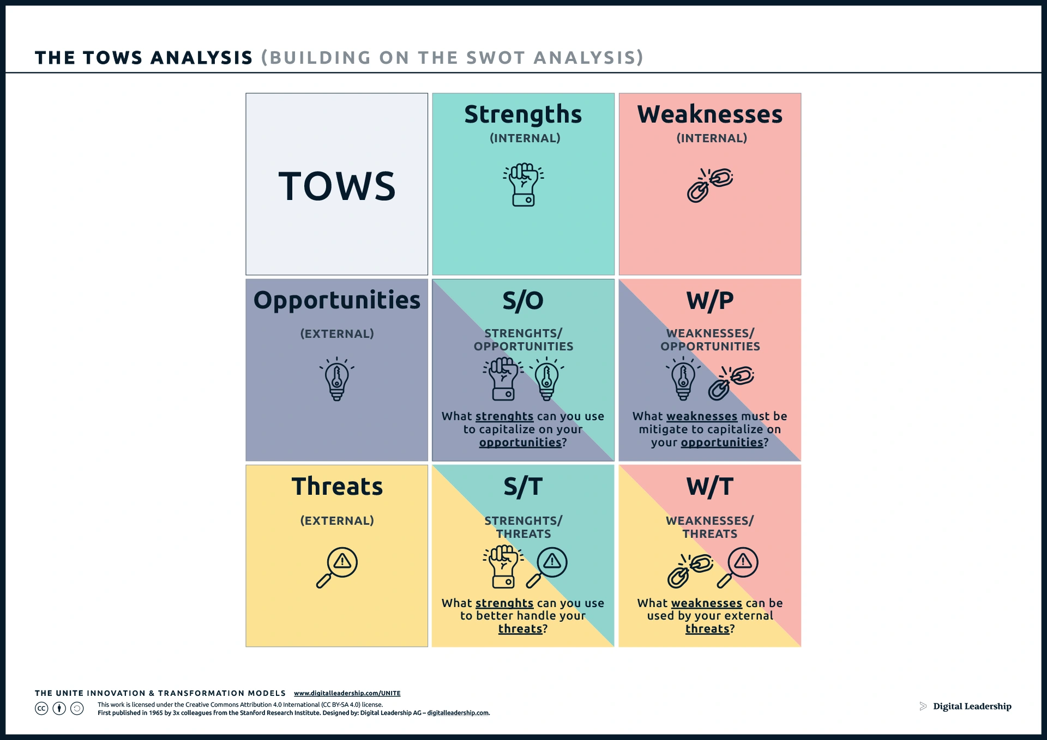  - Topics from discussions  - Role of law enforcement  - Upstream efforts to improve protective factors  - Reduce stigma, promote open conversation  - Effect of suicide death on families  - Training for schools and places of worship  - Incorporating peer and lived experience particularly in training efforts.  - Boiled down to six themes:  - System development  - Workforce development  - Communication  - Education, Training, and Technical Assistance  - Public Health  - Promoting stories of resilience and recovering rather than just data  - Committee wants to see more work supporting those who are left behind after a suicide and increase awareness among those experiencing suicidal thoughts that their decision affects others around them  - Department of Health Nick Nichols has been developing a postvention-specific strategic plan  - Data says one suicide affects, on average, 100 people  - Legislative language also specifically names postvention as area of focus  - Treatment and Intervention  - Evaluate standards of care in various settings such as the emergency department vs. primary care  - Defining best practices for each of these settings to build confidence to treat suicidal ideation  - Integrated health systems to facilitate warm hand-offs between different care settings  - Define warm hand-off: designated agency or primary care office makes contact with the setting of initial contact to share client information (to the extent that the client is comfortable) and schedule appointment for ongoing treatment.  - Can this definition be improved to be easier to communicate.
Committee Business (continued) | Thelma motioned to approve December 2023 minutes. Marla seconded. All in favor. December minutes approved.  ANNOUNCEMENTS  - Vermont Psychiatric Survivors has a new Executive Director, Walt Wade  - Vermont Psychiatric Survivors will be conducting a listening tour in March or April. Zach will provide more info later.  - Upcoming: Mental Health Advocacy Day Monday, January 29th, 10AM-2PM via Zoom. (Ann will reach out if there are more details)  - Legislative Advocacy Training on January 22nd, 12PM-1PM  - More info and registration: Mental Health Advocacy Day - NamiVT  Committee would like to prioritize increasing membership and filling demographic gaps  - Lauren will compile demographic data summary to help identify membership gaps (see below)  - Current membership (representation and affiliation are not discreet counts; there may be overlap)  Age County  40-49 2 Chittenden 2  50-59 1 Orange 1  60-69 5 Rutland 1  70+ 1 Washington 4  Windsor 1  Representation Affiliation  LE 7 DA 4  Family 3 NAMI 2  Staff 4  - Membership gaps  - Regions missing: Northeast Kingdom, Franklin/Grand Isle, Bennington, Windham, Lamoille, Addison  - Age ranges missing or underrepresented: under 40, 50-59, over 70  - We have not collected race/ethnicity data, so committee membership cannot be stratified that way. Initial observation indicates the committee has no Asian representation. Unsure of Latinx or Native American representation.  - Bruce is a member Green Mountain Transit’s Justice, Equity, Diversity, and Inclusion (JEDI) committee and would like to facilitate collaboration with Adult Mental Health State Program Standing Committee  - Can designated agencies coordinate trainings for bus drivers to handle mental health emergencies?  - Can DMH use any grant money to leverage advertising space on buses and at stations?  - Ann suggested GMT collaborate with Vermont Psychiatric Survivors and/or NAMI Vermont  - Are there big annual events that elevate mental health in a celebratory way? Mad Pride, NAMI walks, DMH conferences, Mental Health Awareness Day, Mental Health Advocacy Day  - Ann will share info about upcoming Advocacy Day  - Email Bruce if there are additional collaborators he should explore  - What other collaborations can the committee facilitate?  - Discussion of shortening the meeting to 2 or 2.5 hours, especially for recruiting.  - Marla motioned to officially move to 2.5hr meeting (to be reassessed in future). Lynne seconded. All in favor. Motioned passed.  - When recruiting new members, be transparent that meetings have historically been 3hr, but committee has recently moved to 2.5hr meetings, but that might change.  Committee entered break at 1:30pm.
Presentation: Value Based Payment Methodology and Data | Eva Dayon (they/them), DMH Housing Program Administrator (eva.dayon@vermont.gov)  Committee reconvened at 1:41pm.  - Define value based payment: DMH tracks data from several difference measures (see table below). DAs receive part of their payment from the State based on how well they can meet specified targets  - Eva discussed value based payment expectations that are currently in place for DAs as well as measures that might be implemented if we keep moving toward Certified Community Behavioral Health Clinic (CCBHC)  - Comments about survey measures:  - Understandable to see lower numbers for “services made a difference” because often the people receiving services face challenges to income, employment, housing, etc that aren’t directly related to treatment or to their mental illness.
Discussion: Top Priorities for 2024 | Replace item #5 with more specific language:  - Option 1: Reduce the use of Emergency Departments as Mental Health Parking Lots.  - Option 2: Reduce Emergency Department wait times for mental health concerns.  Marla motioned to adopt new language for priority #5. Thelma seconded. Discussion ensued. All in favor of Option 1. Motion passed.  Lauren will bring data about ED wait times to February meeting.
Public Comment | No members of the public were present.
Closing Meeting Business | Ideas for next meeting (February 12, 2024)  - SPSC Business  - Leadership update: Goals for legislative session (60 minutes)  - Review UCS Agency Designation materials (45 minutes)  - Debrief Mental Health Advocacy Day  Thelma motioned to adjourn. Meeting adjourned 2:36PM.
Links | - More info about SWOT/TOWS analyses: https://www.mindtools.com/auqstul/the-tows-matrix  - NAMI VT Mental Health Advocacy Day: https://namivt.org/mental-health-advocacy-day/
Parking Lot | February meeting will include review of UCS agency designation materials and meet & greet with Mobile Crisis (postpone to March with maybe a bit about 988 outcomes)?  Committee would like more opportunity to discuss housing. Ask the communications director of HomeShare to visit the committee to raise HomeShare’s awareness of mental health and reduce stigma)  Committee would like Chris Allen to return when he has more time to discuss Suicide Prevention in more depth.  Other interests:  - Advanced directives (especially related to how they’re enforced for mental health care) – possible visit from Legal Aid (look into Mental Health Law Project) or Disability Rights Vermont (planned for April???)

Crosswalk of Mental Health Care Rate Value Based Payment Measures
and
Certified Community Behavioral Health Clinic (CCBHC) Clinic-Collected Quality Measures and Bonus Payment Measures

Access to Care Measures
MH Case Rate & VBP (Not NFI) | CCBHC Clinic-Collected Quality Measures | CCBHC Quality Bonus Payment Measures
Measure: Percent of clients offered a face-to-face contact within five (5) calendar days of initial request  Target: 54% | Measure: Time to services: initial clinical services (should be within 10 business days for non-crisis needs)  Target: Reporting only | Measure: Time to services: initial clinical services (should be within 10 business days for non-crisis needs)  Target: To be determined
Measure: Percent of clients seen for treatment within fourteen (14) calendar days of assessment  Target: 50% | n/a – captured above | n/a
n/a – through other processes DMH requires an assessment within 45 days | Measure: Time to services: initial evaluation (can be up to 60 days for initial evaluation)  Target: Reporting only | Measure: Time to services: initial evaluation (can be up to 60 days for initial evaluation)  Target: To be determined
n/a | Measure: Time to services: crisis services (within one business day if contacting for emergent support, which is different than mobile crisis request)  Target: Reporting only | Measure: Time to services: crisis services (within one business day if contacting for emergent support, which is different than mobile crisis request)  Target: To be determined

Adult Needs and Strengths Assessment (Adult Only)
MH Case Rate & VBP (Not NFI) | CCBHC Clinic-Collected Quality Measures | CCBHC Quality Bonus Payment Measures
Measure: % of clients with a completed ANSA within the past 12 months of receiving services  Target: ANSA: 35% | n/a for a comprehensive tool, but does require the following that can be met through ANSA:  Measure: Screening for Social Drivers of Health  Target: Reporting only | Measure: % of clients with a completed ANSA within the past 12 months of receiving services  Target: To be determined

Screening Measures (Adult Only)
MH Case Rate & VBP (Not NFI) | CCBHC Clinic-Collected Quality Measures | CCBHC Quality Bonus Payment Measures
Measure: % of adult clients with an assessment who have been screened for depression  Target: 63% | Measure: Screening for Clinical Depression and Follow-up Plan  Target: Reporting only | n/a
Measure: % of adult clients with an assessment who have been screened for substance use  Target: 63% | Measure: Preventive Care and Screening: Unhealthy Alcohol use: Screening and Brief Counseling  Target: Reporting only | Measure: Preventive Care and Screening: Unhealthy Alcohol use: Screening and Brief Counseling  Target: To be determined
Measure: % of adult clients with an assessment who have been screened for psychological trauma history  Target: 62% | Measure: Screening for Social Drivers of Health  Target: Reporting only (see note above re: ANSA) | n/a

Positive Outcomes
MH Case Rate & VBP (Not NFI) | CCBHC Clinic-Collected Quality Measures | CCBHC Quality Bonus Payment Measures
Measures:  - Percent of clients indicate services were “right” for them;  - Percent of clients indicate they were treated with respect;  - Percent of clients indicate services made a difference  Targets: Right 83%, Respect 83%, Difference 76% | n/a for CCBHC clinic-collected measures, but required for CCBHC State-Collected Measures (statewide, aggregated measures reported to SAMHSA) | n/a
n/a | n/a | Measure: Initiation and Engagement of Substance Use Disorder Treatment  Target: To be determined
n/a | n/a | Measure: Initiation and Engagement of Substance Use Disorder Treatment  Target: To be determined
n/a | n/a | Measure: Follow-up after emergency department visit for substance use (ages 6-17 years; ages 18+)  Target: To be determined

Most Recent Aggregated Value-Based Payment Data